CSCI 370 Final Report

[team name]
[author 1 name]
[author 2 name]
[author 3 name]
[author 4 name]
[author 5 name]
Revised May 23, 2023

[optional graphic or logo]

CSCI 370 [semester] [year]
Mr./Ms./Dr./Prof. [advisor name]

Table 1: Revision history
This will be updated with each submission
Revision | Date | Comments
New | May 27, 2020 | Completed Sections:  - Introduction  - Functional Requirements  - Non-functional Requirements  - Risks  - Definition of Done  - Team Profile  References  Appendix A – Key Terms
Rev – 2 | July 3, 2020 | Updated Sections  - Introduction  - Functional Requirements  - Non-functional Requirements  Completed Sections:  - System Architecture
Rev – 3 | August 20, 2020 | - Minor typos and references

Table of Contents
I. Introduction 2
II. Functional Requirements 2
III. Non-Functional Requirements 2
IV. Risks 3
V. Definition of Done 3
VI. System Architecture 3
VII. Software Test and Quality 3
VIII. Project Ethical Considerations 3
IX. Project Completion Status 3
X. Future Work 3
XI. Lessons Learned 3
XII. Acknowledgments 3
XIII. Team Profile 4
References 5
Appendix A – Key Terms 6

I. Introduction
NOTE: Update this section as the design progresses and research continues
Context of the project
- High level scope/description of the project
  - What is the purpose/goal?
- Client
  - Who are they?
  - Why do they want/need this?
- If applicable, previous software revisions
  - What is the basis of existing software platform?
  - Who developed existing software platform?
  - Why is there a need for continued effort?
- If applicable, source of data
- If applicable, description of hardware interface
- Description of definitions, acronyms and abbreviations
- Who will be the stakeholders/users of software?
- Who will be responsible for maintaining software?

II. Functional Requirements
NOTE: Update this section as the design progresses and research continues
Highlight critical functional requirements
Elements must be specific and testable
Avoid subjective requirements (e.g., easy to use)
While introducing table, discuss critical functional requirements and/or any critical relationships between requirements

III. Non-Functional Requirements
NOTE: Update this section as the design progresses and research continues
The above functional requirements are supported by non-functional requirements (also known as quality requirement), which impose constraints or design or implementation
Examples include performance requirements, cost constraints, security or reliability.

IV. Risks
Assess the risk associated with both technical and skills related issues.
For each risk identified discuss:
- Likelihood (Unlikely, Likely, Very Likely)
- Impact (Minor, Moderate, Major)
- Risk mitigation plan

V. Definition of Done
- List of minimal useful feature set
- Describe any tests that client will run before accepting software
- Specify how/when product will be delivered

VI. System Architecture
Discuss the fundamental foundation of the system architecture before introducing. If using 3rd party elements, be sure to include how they integrate into architecture.
Depending on your project, your system architecture might be best described as an:
- architecture diagram
- UML diagrams
- database schema
- flowcharts,
- finite state automata
- wireframes (screen layouts)
- other relevant figures or a combination of any of the above

VII. Software Test and Quality
Reference the functional and non-functional requirements when creating this plan. There should be a corresponding test plan for every requirement.
Every test plan should include:
- Purpose of test
- Description of test
- Tools utilized/required for test
- Threshold for acceptability – relate to requirement specification
- Edge Cases
- Results of testing

VIII. Project Ethical Considerations

IX. Project Completion Status
Summary of project completion.
- Features implemented and summary of feature performance
- Features not implemented

X. Future Work
Recommendations for future work. Be sure to include:
- Resources required (hardware, software, licensing, etc.)
- Knowledge/skills required
- Estimate of time required to implement

XI. Lessons Learned

XII. Acknowledgments
- Thank your client and technical advisors

XIII. Team Profile
Headshot of team member (optional)
Software/Engineering Discipline
Hometown
Work Experience
Sports/Activities/Interests

References
All references must be numbered in the order they are cited within the text
Formatted per IEEE format
Be sure to include citations for interviews.

Example:
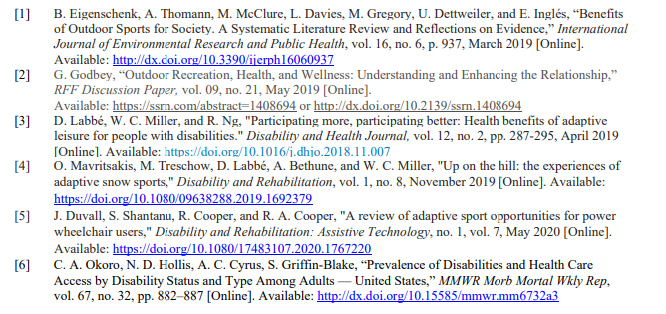

Appendix A – Key Terms
Include descriptions of technical terms, abbreviations and acronyms
Term | Definition
[Insert Term] | [Provide definition of the term used in this document.]
[Insert Term] | [Provide definition of the term used in this document.]
[Insert Term] | [Provide definition of the term used in this document.]

