Data Verity
Website User Interface
Data Verity 2

Client Report

Max Carey
Raul Rangel
Richie Zirbes

Computer Science Field Session
June 18, 2008
Table of Contents

Abstract 2
Introduction 2
Requirements and Specifications 4
Project Requirements 4
Project Deliverables 4
Solution Approach 4
Project Tasks 5
Project Estimates 5
Project Time Line 10
Project Risks 11
Implementation and Results 12
Analysis: 17
Memory Management Tests: 17
Tools: 19
Conclusions and Future Directions 20
Appendix A: User Help Manual 21
ESP Help Information 21
1. Desktop 21
2. Start Menu 21
3. Programs 22
Glossary 30
References 31

Abstract

Companies are always looking to have the competitive edge in their market. For businesses based online, this usually means implementing the latest hardware or software. All online websites inherently have some type of interface, moving more and more toward specifically designed graphical interfaces. A Graphical User Interface (GUI) is more than likely all a user of a website will ever see, this makes the design especially important. All things constant, users prefer graphical technology that is the simplest and sleekest. Making the interface appealing and stylish gives it more attention, while adding to its’ ‘wow’ factor, allowing a particular business to be a step ahead of the competitors.

User applications have been moving off stagnant PCs, and onto the Internet because of communication and flexibility. All a person needs to create files and documents and communicate with the rest of the world is a web browser. As a result, many programs and frameworks exist for developing such interfaces, making it easier and cheaper than ever to create rich web applications.

Data Varity, a local Golden business, services their customers through an online interface and has been interested in converting their current website into a more appealing, easy to use interface for their customers. As well as pleasing their current customers, they hope to increase efficiency as well as attract attention to entice more customers to use their services.

Introduction

Data Verity is a data analysis company run by two brothers, David and Gordon Flammer. Their customers hire them to compile data into comprehensive graphs and reports that will allow them to increase their efficiency. The type and amount of data varies for each client, but most clients are financial institutions (e.g. banks, credit unions) who are interested in analyzing similar sets of data. A simple example of a data set is a list of sales that can be used to determine employee incentives.

Their current website allows the users to enter and edit related information and generate any number of reports based on the data for any given time frame. A client uploads data to a server through the Data Verity website. The data is processed on the server, and a number of reports are generated that the client can view on the website. Data remains on the Data Verity server even after it is viewed. A client can also correspond with other users of the website through a case management system called the “Collaborative Online Management” (COM) system. The COM system works much like email, allowing users to send, receive, and forward messages. They receive customer suggestions and are constantly updating their site to fit their clients’ needs.

Data Verity is unsatisfied with the current layout of their website. They believe certain aspects of the layout and navigation to be counterintuitive. For instance, a user navigating through the site is forced to open a number of pop-up windows. Data Verity thinks these pop-ups can be confusing to users.

The architecture of the website is divided into two layers: front-end and back-end (see Figure 1). The back-end is responsible for adding data to the database, processing data, and sending the results of processing to the front-end (in a certain format). The front-end is responsible for displaying the website in a browser, accepting user input, and displaying the reports generated by the back-end. Currently the back-end is written in PHP and uses MySQL; the front-end is written in HTML and JavaScript.
The company would like to improve the layout, organization, and navigation of their website in order to make it more user-friendly and intuitive. They have been interested in overhauling the front end of their interface to make it more user-friendly. They have looked into several online frameworks, based on JavaScript and AJAX (Asynchronous JavaScript and XML) that will facilitate this transition and not require them to code from scratch. Our task is to design an improved site layout and to implement it on top of the current back-end.

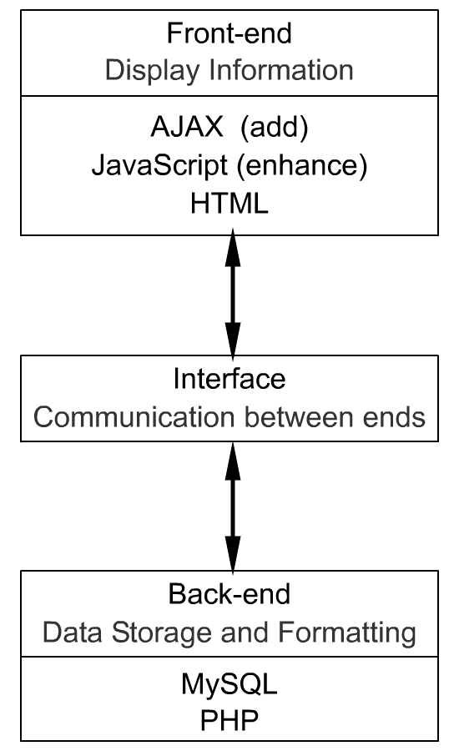
FIGURE 1 – Current website design, and probable enhancements.

Requirements and Specifications

Project Requirements

The following are Data Verity's requirements for a solution, as we understand them.

Non-functional Requirements

The solution must:

1. Work on top of the current back-end.
2. Have an intuitive layout that is consistent across pages.
3. Include help files that users can access from the website.
4. Eliminate pop-up windows.
5. Decrease the use of HTML frames seen in the current website.

Functional Requirements

The solution must allow users to:

1. Log in and out of the system.
2. Upload data to the server either one entry at a time or in CSV format.
3. View uploaded data.
4. View various reports generated by the server.
5. Sort the information in the reports.
6. Export the reports to PDF format.
7. View, send, and receive messages through the COM system.

Most of the functional requirements listed are already implemented in the website, and we are expected to maintain the current functionality in our solution.

Project Deliverables

Data Verity expects us to deliver a solution in the form of HTML and JavaScript files. When uploaded to the Data Verity server, these files should replace the current front-end of the website.

The company also expects a complete and thorough set of help files. These files will be available to website users. Our work must also be documented so that Data Verity can easily implement changes to our design in the future.

Solution Approach

Project Tasks
The project can be divided into 4 main sub-categories and a combining portion. The website’s four main individual functions are: entering data, report viewing and creation, COM management and employee management. Our task is to produce a working user interface allowing users to fully access all aspects of these functions (for their given level of authority). Because this is a web application, in agreement with our client, we decided the best solution would be to use an already existing JavaScript framework as the base for our user interface.
In the spirit of using already tested frameworks, we researched several of the better solutions:
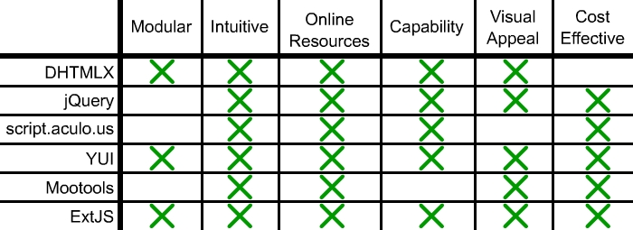

FIGURE 2 – Comparison of multiple JavaScript based frameworks.

After meeting with the client, we all agreed ExtJS would be the best solution to implement our GUI because it has a modular design, there are plenty of examples online to look through and its’ base graphics are very visually appealing. It comes with an example desktop-interface that most computer users are familiar with and it's cost effective for our client. We decided to use the ExtJS framework's desktop as the base interface for the website, and have each of the four separate functions appear as four separate applications the user can run in different windows.

Project Estimates
After walking through several preliminary designs for the window designs with the client, we came upon our base window designs to work off of:
Data Entry:
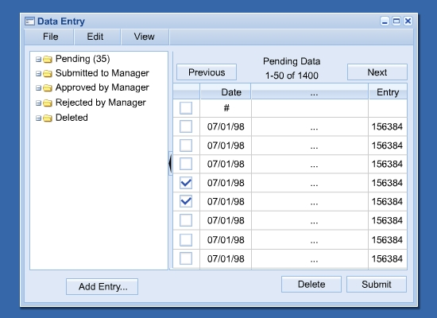

FIGURE 3 – Data Entry concept window.

The data that the site runs off of is organized into Pending (data just entered by the user), Submitted (data entered and submitted to the manager, awaiting approval), Approved (data that a manager finds acceptable and is now in the system of usable data), Rejected (data the manager has a problem with for whatever reason), and Deleted (data for whatever reason isn't needed anymore). There can be thousands of entries under each category and we have represented this as a tree. Clicking on a folder will reveal all the entries under it, and update the chart on the right with the underlying information for each category. A user can then edit and add data accordingly.
Approx. 40 hours of work.
Reports:
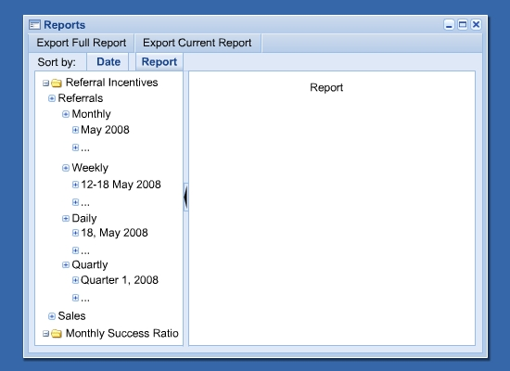

FIGURE 4 – Reports concept window.

Using the approved data in the system, the user can create reports. There are two different types of reports: Incentives and Success Ratios, which can also then be subdivided into the specific log types (i.e referrals and sales). These can be analyzed over any variation of time: daily, weekly, monthly, yearly, or quarterly as long as the information is available. Again, we decided a tree was the best way to organize these data options.
Approx. 30 hours of work.
COM Entries:
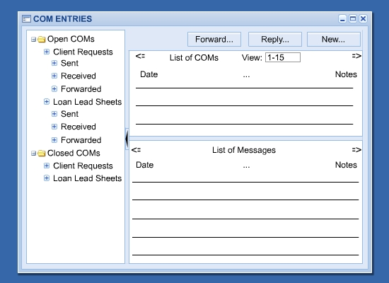

FIGURE 5 – COM Entries concept window.

The Collaborative Online Management system is a way for the users of the organization to communicate with each other about clients and data. It dissolves down into a basic email system, where COMs are either open or closed, and can be divided into Client Requests or Loan Lead Sheets which can then be under sent, received, or forwarded.
Approx. 40 hours of work.
Employee Manager:
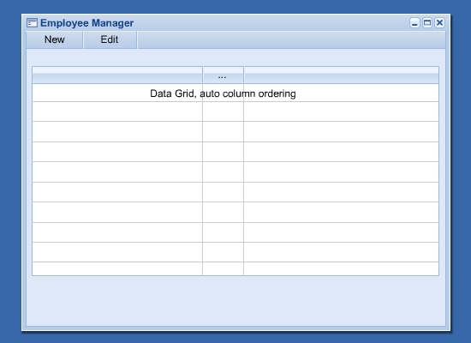

FIGURE 6 – Employee Manager concept window.

This is a basic management application, allowing someone with higher permissions to add and edit employees in the organization. The grid displays the current employees in the system and clicking on the top row allows for the user to add a new employee.
Approx. 30 hours of work.
Because the framework and project requirements are so modular, we divided up the workload as follows: Each member will be assigned to code a separate application window. Each window will have two phases, they will start off as static representations of our final working system then we will add the according code to make it dynamic. The final fourth window, the combining of the windows and the creation of a desktop will all be worked on together.

Combining:
This is the compilation of each of the application windows into a desktop (webtop) and adding the logging in and out of the system ability.
Approx. 20-40 hours of work.
Testing:
We have been given our own test server, with test data, where we can develop and test our solution as time goes on, without interfering with the company's day-to-day activities. We will do a majority of the testing while we program our individual pieces, but will do final testing once it is all pieced together. Any discrepancy we have in our project timeline will probably happen here, as this is directly related to possible unknown problems that may occur.

Project Time Line
We divided our work over the remaining four weeks as follows:
Week 1 (May 26 - May 30): Create JavaScript mockups of each of the four modules. These mockups will be working JavaScript code using the ExtJS framework. When a mockup is loaded through an HTML page, the user will be able to navigate around the mockup (navigate through menus, select tabs, etc). The mockups will not interface with the website back-end; rather, they will use made-up data sets. However, they will have as much functionality as possible without communicating with a database. These mockups will give the client a good idea of what the final product will look like.
Week 2 (June 2 - June 6): Turn the static mockup dynamic by using actual database information and PHP variables in existing code. This will test the application windows with existing data to allow actual interaction with the database and alter/add data. We will code the desktop interface and combine the applications to run inside, as well as incorporate a logging in and out system.
Week 3: (June 9 - June 13): Finish any testing or elimination of bugs and write the project final report. Discuss final result and possible additions with the client.
Week 4: (June 16 - June 20): Final week project wrap-up. This will allow us additional lag-time in case the project takes more time than expected.
June 18: Formal final product delivery date, when we will give the completed code to the client, and discuss the product.

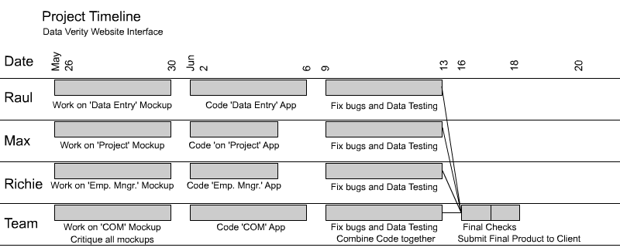FIGURE 7 – Project Timeline
Project Risks
There are some issues that could impact our completion of the project. They are:

Difficulty interfacing our work with the current website back-end: Currently, the back-end delivers data to the front-end in a very specific manner. For instance, when the back-end generates a data report, it sends it to the front-end by filling in an HTML template. The front-end simply displays the HTML page created by the back-end. However, one of our requirements is to add sorting to the reports. It would be difficult to sort an HTML table, so some re-working of the back-end may be required in order for us to meet this requirement.

Difficulty making our solution extensible: Data Verity currently supports a limited number of clients, all of whom are interested in processing similar data. However, the company wants to be able to process a variety of data from a variety of companies, therefore they want our solution to be extensible. This may be difficult because some things cannot be hard-coded; as an example, table headings.

Difficulty in coding: It is possible that we may have problems using the ExtJS framework, which may set us back somewhat until a workaround solution is discovered. We will be learning a new language and a new framework, and the possibility exists that we may run into something we are unsure how to implement.

Implementation and Results

Once we decided to work with the ExtJS framework to develop our solution, each team member researched, learned, and experimented with the code independently to give us a handle on how objects and items are used.

We began with meetings where the client explained the how the current website operated, what the important variables are, how data is formatted, the use of POST variables, security-related concepts and other useful information. We were all given usernames and passwords to log into the Data Verity server via SSH (Secure Shell) and a testing copy of their current website was set up for us to use. Once we felt comfortable with how everything worked, we began working on our respective windows independently.

After a short period of working separate, only contacting each other over email and regrouping for meetings and questions, we all worked together alongside David, developing our pieces, adjusting them to be dynamic, and getting communication across the pages to work. David took care of adding or altering any back-end processing that needed to be done in order to communicate with our windows and deliver the correct information. We also developed the desktop, giving it icons to remotely pop-up windows, as well as adding the logging in and logging out abilities.

Due to some confusion in the framework the windows took slightly more time to implement than we had anticipated. Once we arrived at the point to add in sub-windows to correlate with our main windows, where we were to allow the users to insert and edit data, we ran into a stumbling block of having to check and verify the users’ data. This was a problem because it wasn’t normal validation, it required calls to the server to get arrays of information about how the data was to be evaluated, and what was and was not allowed. The evaluation data would possibly be different for every field in a window form, and required great extensibility. Our client had informed us of this requirement at the beginning of the project, but we had not anticipated it being a problem in the ExtJS framework. We would be able to fix these problems, but due to time constraints and in order to end up with a useable product, we needed to leave them out and changed what the expected solution would be.

Instead, we decided to copy the existing pages of the current website into the sub-windows of out main programs. ExtJS made this ability easy, with a few modifications and we were able to keep all the functionality of the old website working inside of the new desktop.

Because the coding took longer than expected, each team member was greatly involved in his own work, and as a result, the COM Window was put on the back burner. We were only able to get working on it as a team the last few days, and as a consequence, it isn’t fully developed.

The windows in our final product ended up as follows:

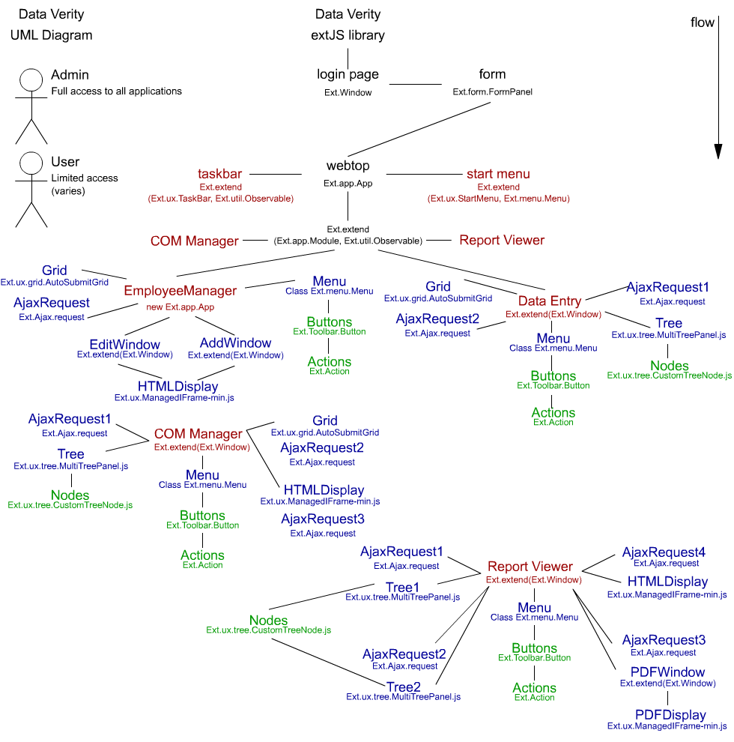
FIGURE 8 – UML Design of Data Verity Website

Login Window:
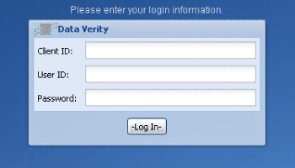
FIGURE 9 – Login Window

Desktop:
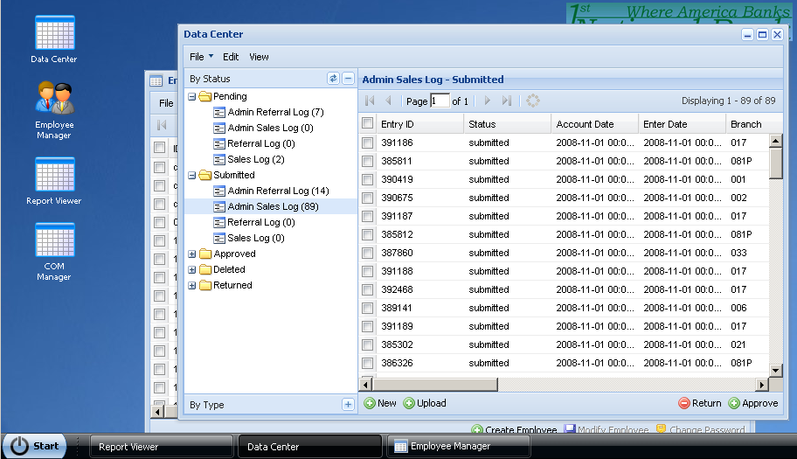
FIGURE 10 – Desktop

Start Menu:
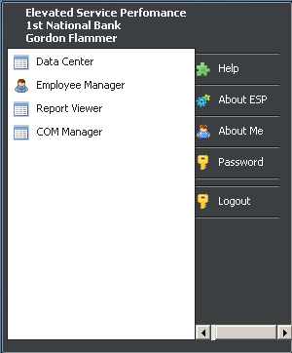
FIGURE 11 – Start Menu

Employee Manager:
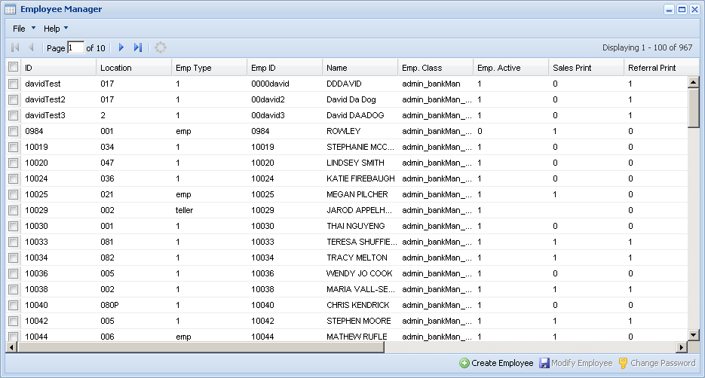
FIGURE 12 – Employee Manager Window

Report Viewer:
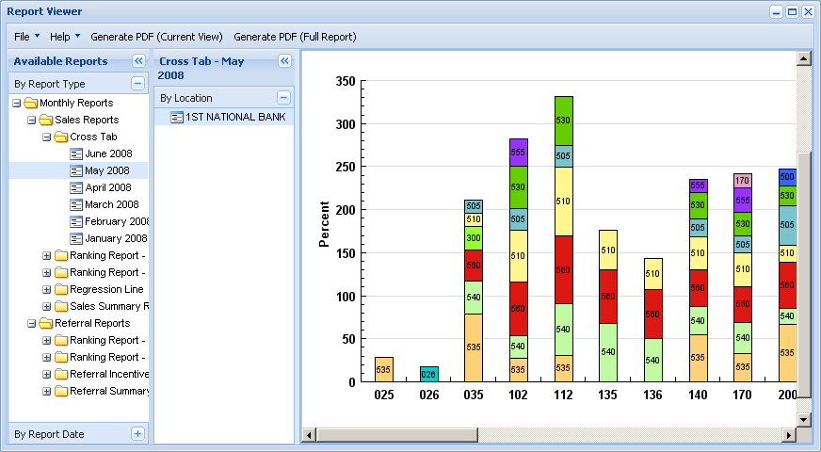
FIGURE 13 – Report Viewer Window

Data Center:
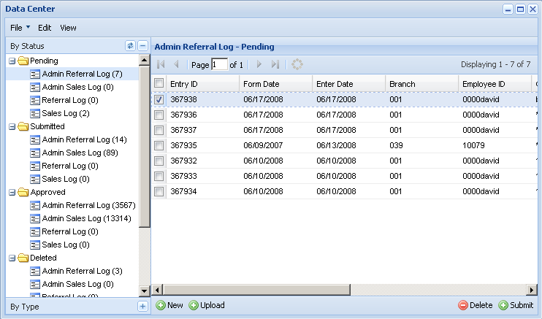
FIGURE 14 – Data Center Window

COMs Center:
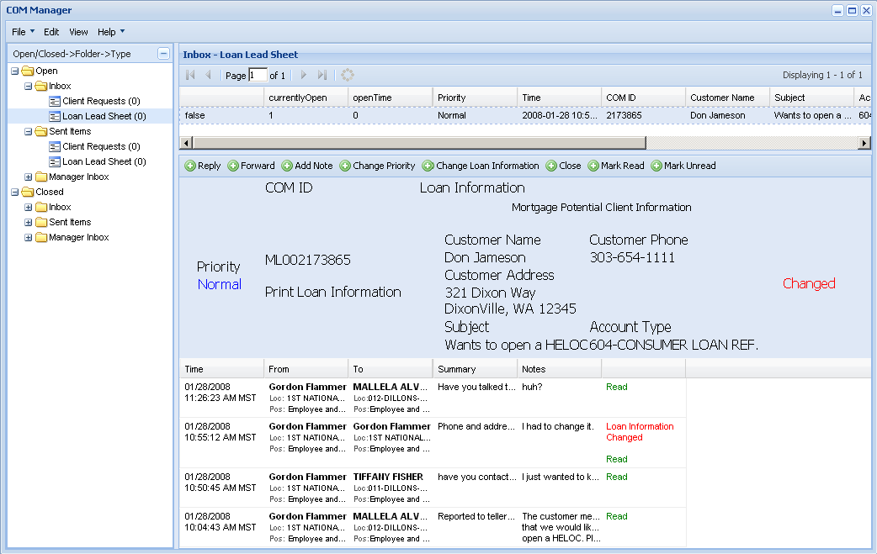
FIGURE 15 – COM Manager Window

Analysis:

The new design is very pleasing to the eye. It behaves just like any of the desktops used by the known operating systems, the navigation is simple, and the functionality is logical. Only remaining problem is that the COM Manager window, while functional, is not fully complete. We performed some tests of our product on Firefox and Internet Explorer browsers to check for any anomalies, and everything appeared to work fine.

By using new methods of passing data and moving the formatting onto the user side, David noticed the new system now had less data traffic. By storing more information on the user end, he also estimated that it decreased database calls by about 70%, lessening the load on the server. (Note we have no data for this, it is an estimate made by David Flammer)

Memory Management Tests:

Our team went through the website, performing simple tests to see how much memory our pages were using. We went through a simple procedure of loading certain parts of websites, and using Windows’ Task Manager, recorded the memory usage. These are the results:

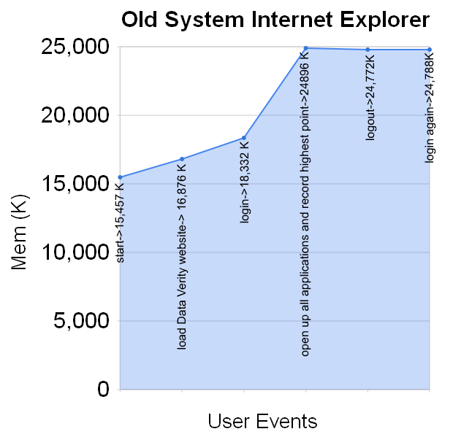
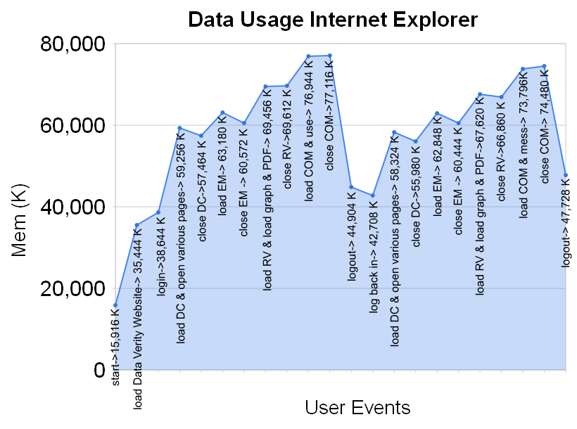

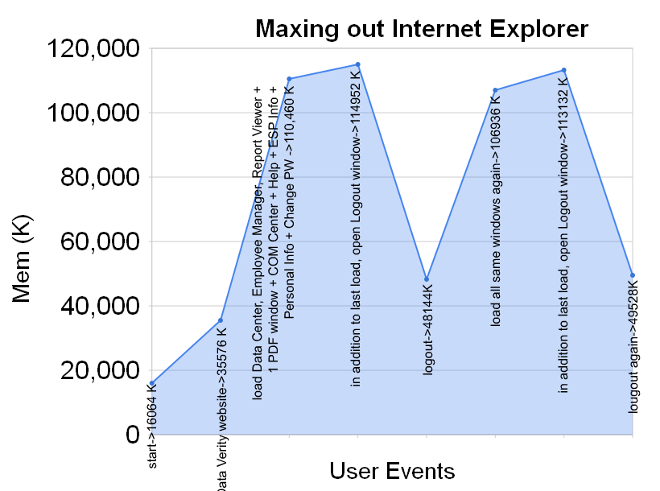

Analysis:

We expected our solution to use much more memory, as our interface has dozens of images and hundreds of elements, and the old system was simple HTML with popups that freed memory back as soon as they were closed. We expected some memory leaks, but as the graphs show, the memory peaks and never gets as high again. However, at each subsequent login screen, after logging out, there is more memory used than at the previous login screen, so it is inconclusive. If we had more time, would like to have perform more (and more thorough) tests on the interface, but these graphs provide at least some insight.

Tools:

The tools we used to develop the solution were:
Firefox and Internet Explorer Browsers – to test the website in, and search for questions and information about ExtJS

FireBug & Microsoft Script Debugger – to debug web pages when errors arrived.

Emacs, Vim, UltraEdit – to write the code in.

Task Manager – to record Memory usage of programs.

Google Docs – to create new documents, spreadsheets (and graphs) and presentations.

Conclusions and Future Directions

David and Gordon are easy going clients, keeping us all on a first name basis. They worked extensively along side us, facilitating the process. They were very helpful with any questions we had, and they made working with them on their website a comfortable environment where we enjoyed coding. As with learning anything new, we had some problems with understanding some of what was foreign to us. We also had difficulty finding answers to some specific questions we had about the ExtJS framework.

We’re now more comfortable working with JavaScript, would be able to bring more to the table on our next jobs. We were not able to fully integrate the old website into the new design, but by including some pieces of the old website, we were able to leave David and Gordon with a functional website that includes the new design. David and Gordon will continue to update their interface to the new implementation.

Appendix A: User Help Manual

ESP Help Information

1. Desktop
From here you can access all of the features of the Elevated Service Performance (ESP) system.
The desktop is your main access to ESP. This window should never be closed during a session. When you are finished working with ESP, you should select the Log Out button from the Start Menu , at the bottom left of the screen.
You can access the four main programs of the ESP system by clicking on the icons located at the left side of the screen. You can also access these programs by clicking on the Start Menu and clicking on the one you wish to open.

2. Start Menu
From here you can access the four main programs of the ESP system. Each program is also accessible from the Desktop , by clicking on the icons located at the left side of the screen.
You can also access the ESP System and Personal Information:
 | 2.1 | System and Personal Information:
   | 2.1.1 | Help: This window, where you can find information about how the various aspects of the ESP system work.
   | 2.1.2 | About ESP: Here you can find the ESP version, last modified date, and contact information.
   | 2.1.3 | About Me: Edit your personal information.
   | 2.1.4 | Password: Change your current password.  Allows you to change your password. You must enter your old password, and your new password in duplicate. Your password must be at least seven characters long and contain at least one lower case letter, one upper case letter, one number, and one special character (e.g. #, %, &). When finished entering your password information, click the Change Password button, and your new password will be in effect.
   | 2.1.5 | Logout: End the session and return to the Login page. All desktop windows will be closed, and any unsaved data will be lost.

3. Programs
These are the four main programs of the system, accessible by the clicking the icons on the Desktop , or by selecting them from the Start Menu .
 | 3.1 |  | Data Center:
   | 3.1.1 | Layout:  At the left of the window are two trees allowing data to be arranged by Status or by Type . Clicking on the tree panel title or the +/- icons opens/closes the tree view. With a tree opened, clicking on the refresh icon updates the data in the current tree. The numbers at the right of the selections refer to the number of records in that section. Clicking on an entry in the tree will open up the relative data into the graph at the right.  At the Right side of the window is a graph with the relative data information that is generated after clicking on an entry item in either of the trees at the left. To scroll between pages, click on one of the arrow keys located at the upper left corner of the window. After selecting an entry you may also choose to Delete, Submit, Return, Approve or Restore the entry by selecting the buttons at the bottom right of the window (Only certain buttons are available, depending which category of data you are viewing). Clicking one of these buttons will send the data to the next level of validation or delete/return it.
   | 3.1.2 | Data Organization:
     | 3.1.2.A | Filtering:  By clicking on the column header, you can filter the data ascending or descending. When hovering over the column title, clicking on the arrow will bring up a sub-menu, with further selections. You can again choose to sort ascending or descending, choose which columns to include/exclude, and enter filtering information for the data.
     | 3.1.2.B | Status:  Pending: Data that has been entered into the system, but not sent anywhere.  Submitted: Data that has been submitted for approval, but not yet reviewed for approval by management.  Approved: Data that has been approved by the management.  Deleted: Data that for any particular reason was removed.  Returned: Data that has been marked as invalid. This shows you a list of which records were rejected automatically by ESP and/or manually by a manager (e.g. for being duplicate information). Once data has been returned, it cannot be validated in the system. If for any reason,returned data should have been validated, it must be re-entered.
     | 3.1.2.C |  | Type:  Referral Logs: Data based on referrals.  Sales Logs: Data based on sales.
   | 3.1.3 | Menu Options:
     | 3.1.3.A | File:  ->Admin Referral Log: Allows user to enter new Admin Referral log.  ->Admin Sales Log: Allows user to enter new Admin Sales log.  ->Referral Log: Allows user to enter new Referral log.  ->Sales Log: Allows user to enter new Sales log.  ->Close: Close the window, and end the program.
     | 3.1.3.B | Edit:
     | 3.1.3.C |  | View:
     | 3.1.3.D | Help:  ->Data Manager Help: Brings up help window at Data Manager Program location.  ->General Help: Brings up help window.
   | 3.1.4 | Pop-Ups:  Entering New Data: After selecting to create a new log from the File Menu , a window like this pops up:  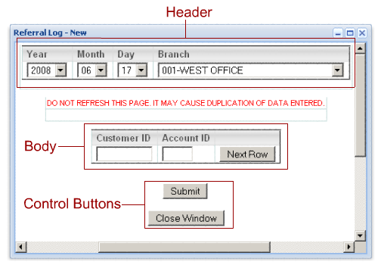
     | 3.1.4.A |  | Header: The Header Information selected when the Submit button is clicked applies to all records entered in the detail pane. After clicking the Submit button, you can then change the header information and enter new data into the body. All data attached to a record can be viewed in the View/Validate Entered Data popup window.
     | 3.1.4.B | Body: The body data contains information that should change from one record to another. You can move from one field to another by pressing either the Tab or Enter key on your keyboard. If there is an error or an invalid entry, red text above the Body will explain the reason for the problem. When you have entered a record, click the Next Row button. A new row will appear. If the ID is the same for the next entry as the previous one, you may skip that field and that information will be automatically entered. (Note: it is not necessary to click Next Row after you enter the last record in the body. While you can Submit with a blank or partially completed row, you will be notified that it will be removed if you continue with the submission.) If you notice an error with a record you entered, you may delete it by clicking Delete under the column on the far right.
     | 3.1.4.C | Control Buttons: Click Submit to submit any information you've entered. Note: any data you enter is not submitted until you click the Submit button. Click Close Window when you are finished working with the popup window. Clicking Close Window will also submit any data you have entered.
 | 3.2 | Employee Manager:
   | 3.2.1 | Layout:  The graph inside the window is a list of Employees and related information. To scroll between pages, click on one of the arrow keys located at the upper left corner of the window. To Create or Modify an employee, or to change an employee's password, click on one of the icons at the lower right of the window.
   | 3.2.2 | Menu Options:
     | 3.2.2.A | File:  ->Close: Close the window, and end the program.
     | 3.2.2.B | Help:  ->Employee Manager Help: Brings up help window at the Employee Manager Program location.  ->General Help: Brings up help window.
   | 3.2.3 | Create Employee:  To create an employee, first enter the employee's ESP login ID and their password. The different sections are as follows:  The User ID: Employee's login ID. This value can contain both letters and numbers, but no special characters (e.g. spaces, hyphens, apostrophes).  Password: Employee's login password. This value must be at least seven characters, and contain at least one lowercase letter, one upper case letter, one number and one special character (e.g. #, %, &). When you are finished entering the employee information, click the Next button and a popup window will appear, where you will have access to further employee information.
   | 3.2.4 | Modify Employee or Change Employee Password:  To modify an employee or change a password, select the employee from the dropdown box, and click the Next button. A popup window will appear where you will have access to further employee information.
   | 3.2.4 | Pop-Ups:  Selecting Create or Modify Employee will being up a window like this:  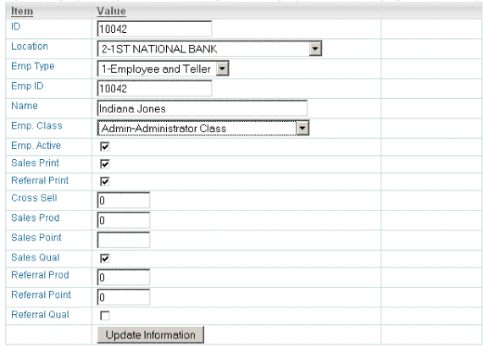  From here you can enter the needed information and when everything is correct, pressing the Update Information button puts all the new values into the database.

 |  | 3.3 |  | Report Viewer:
   | 3.3.1 | Layout:  At the far left of the screen is a panel containing two trees which hold available data to generate reports from, you may either select to view data organized by Report Type or Report Date . Clicking on the tree panel titles or the +/- icons opens/closes the tree view. Clicking on an entry will open the selected report into a second tree panel, where you can select what specific data to generate the report by. Clicking on either a folder or a specific data item will generate the report into the panel at the right. Clicking on the '<<' icon at the top of the tree panels forces the tree to the left, allowing for better view of the report. The trees can be expanded to their original size again by clicking on the '>>' icons at the top of the tree panels.
   | 3.3.2 | Data Organization:
     | 3.3.2.A | Report Type: Reports are organized by their specific types and then by date.
     | 3.3.2.B | Report Date: Reports are organized by date and then by their specific types.
   | 3.3.3 | Menu Options:
     | 3.3.4.A | File:  ->Close: close the window, and end the program.
     | 3.3.4.B | Help:  ->Report Viewer Help: Brings up help window at the Report Viewer Program location.  ->General Help: Brings up help window.
     | 3.3.4.C |  | Generate PDF (Current View):  Opens a new window with a PDF version of the report in the right panel.
     | 3.3.4.D | Generate PDF (Full Report):  Opens a new window with a PDF version of the report from the tree root (whether or not it is in the right panel).
 | 3.4 |  | COM Manager
   | 3.4.1 | Layout:  COM is an acronym, representing: 'Collaborative Online Mangement'. It is a list of messages sent and recieved by personnel, all related to the same topic. 'COM Line' refers to any of these groups of messages. The COM Manager is arranged into 3 main panels. On the far left is the tree panel, which organizes COMs into Opened /Closed -> In/Out message COMs -> COM Type. The numbers at the right of the selections refer to the number of records in that section. Pressing on the minus (-) button brings the tree up, and out of the way. To bring it back up, press the plus (+) button. After clicking on a COM Type, the selected COM Line messages are listed in the top right window. After clicking on one of these COM message lists, the entire COM Line history of messages is opened up in the right bottom panel.  In the right bottom panel, after selecting on a message, you may select from any of the buttons at the top of the panel. Pressing any of these buttons will bring up a pop-up window to allow you to further change the information for the selected message.
   | 3.4.2 | Data Organization:
     | 3.4.2.A | Open: COMs that have not yet been marked as closed, because the issue is still active.
     | 3.4.2.B | Closed: COMs where the issue has been closed, and is not longer active.
   | 3.4.3 | Menu Options:
     | 3.4.3.A | File:  ->Open New COM Line: Create new COM line.  ->Close: close the window, and end the program.
     | 3.4.3.B | Edit:
     | 3.4.3.C |  | View:
     | 3.4.3.D | Help:  ->COM Manager Help: Brings up help window at the COM Manager Program location.  ->General Help: Brings up help window.
   | 3.4.4 | Pop-Ups:
     | 3.4.4.A | Open New COM Line:  After selecting Open New COM Line from the File Menu , a window like this will pop up:  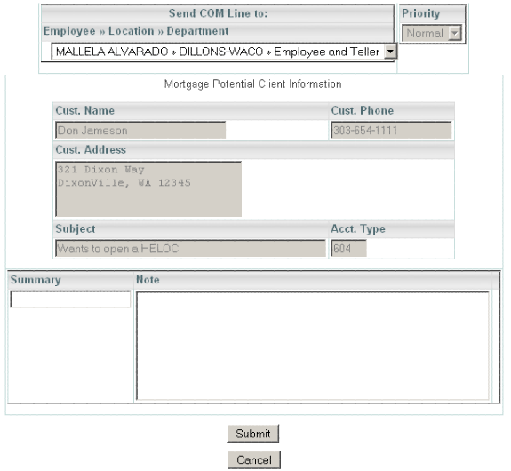  Address: select to whom your are sending the COM Line; click the Manager Assistance button to send the Line to a manager. (Note: any location or department in red indicates there are no available employees in that category.) If Available: Click Change View to search by employee name rather than location. Click the Add CC button to send the Line to more than one person. If you accidentally click the Add CC button, you can leave it blank, and it will ignore the row. (Note: once you add a CC, you lose the ability to toggle the Change View feature. If you wish to change the view after adding a CC, you must close and reopen the window, and all data will be lost). Next enter the Priority of the Line. Fill in the Header information which will be attached to the COM Line throughout its management. Then fill in the Summary and Note. Each time someone changes information of the COM Line or makes any progress with the Line, they will add a new Summary and Note. Once you have entered all information pertinent to the Line, click Submit. To cancel the Line, click Cancel.

Glossary

AJAX: Asynchronous JavaScript and XML, Used to communicate a webpage through JavaScript to another request page to retrieve data, without needing to refresh the entire page.

COM: Collaborative Online Management (System) (COMs for plural), Email-like system Data Verity developed to facilitate communication between personnel in an organization.

Data Verity: Data Analysis Company run by two brothers: David and Gordon Flammer. Based on input data, they provide insight into different aspects of a client’s operations, designed to increase efficiency. Their clients often include financial institutions.

ExtJS: JavaScript Framework designed for customizing website GUIs.

GUI: Graphical User Interface, refers to any components used to communicate between user input and functions.

HTML: HyperText Markup Language, Markup Language used to code documents used for the World Wide Web.

JavaScript: Programming language that provides dynamic features to HTML documents.

MySQL: Open Source SQL database server.

PDF: Portable Document Format, a popular file format used by Adobe, designed to be exchangeable and readable on almost any computer

PHP: Hypertext Preprocessor, Programming Language for creating dynamic data on a web page, often used in communication between databases, documents and files.

References
Data Verity : www.dataverity.net and www.dataverityinc.net

Extjs.com : Extjs.com

