Final Report
USGS Earthquake Notification System

Presented By
Clifford Barnes
Nicholas Brunhart-Lupo
Michael Brunel

Advisor:
Cyndi Rader

Table of Contents
1.0 Introduction 4
1.1 Abstract 4
1.2 Detailed Problem Description 4
1.3 Scope 5
1.4 Overall Description 5
1.4.1 Product Functions 5
1.4.2 User Characteristics 5
1.4.3 Constraints 5
1.4.4 Assumptions and Dependencies 6
1.5 Detailed Existing System Description 6
1.5.1 System Architecture 7
2.0 Specific Requirements 7
2.1 Process and Data Requirements 7
2.2 Performance and Quality Requirements 8
2.3 Requirements Traceability 8
3.0 Our Course 8
3.1 Introduction of ArcIMS 8
3.2 Interfacing with ArcIMS 8
3.2.1 Design Story 9
3.2.2 Story 9
3.2.3 Figures 10
3.2.4 Story Rationale 14
4.0 Implementation and Results 14
4.1 Implementation 14
4.2 Results 15
4.2.1 Primary Goals- Region Selection System 15
4.2.2 Secondary- UI/Functionality Review 15
5.0 Conclusions 15
5.1 Lessons Learned 15
5.2 Future Improvement/Extension 16
5.3 Other Options 16
6.0 Glossary 17
7.0 References 17

Table of Figures

Figure 1 Current System Implementation 6
Figure 2 New region selection tool 11
Figure 3 Solution and Information flow 12
Figure 4 MySQL Database Structure 13
Figure 5 Main Page 14

1.0 Introduction

1.1 Abstract

The United States Geological Survey (USGS) Earthquake Notification System (ENS) is a web service that allows registered users to be notified in the event of an earthquake. Earthquake notifications are filtered by user specified criteria. Users are allowed to select world regions, that they wish to be notified about, and earthquake magnitude. The purpose of this project is to redesign and/or modify the region selection tool and to integrate it with the existing interface. In addition, the intuitiveness of the interface and user friendly orientation is to be analyzed. Changes to the previous two items are to be by suggestion only. USGS does not want the interface code to be changed by our team. Therefore, only the analysis of the interface will be presented.

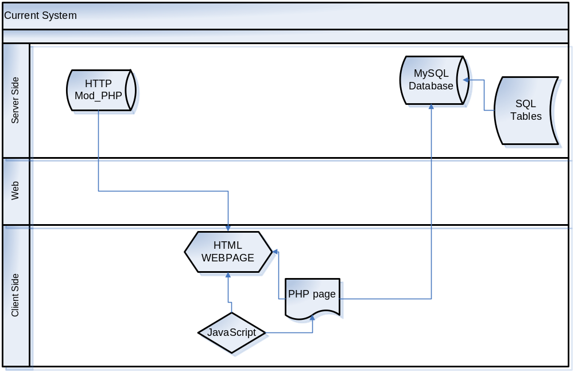
Figure 1 Current System Implementation

1.2 Detailed Problem Description

Currently the USGS-ENS system uses a set of static maps, generated by generic mapping tools (GMT). This hinders the user’s ability to select the region that they want, because they are only able to use the maps that have already been created. The use of static maps leads to other problems as well. When defining your own region by using the n-sided polygon tool, every time you select a vertex, it has to reload the map. This is a huge amount of overhead, and annoying to the user. The current implementation does not provide an undo option, so any mistake forces the customer to start the process over. This problem is not limited to the region selection area, there is no navigation throughout the system. The user either proceeds, or returns back to the main page. In addition to the aforementioned problems, there is also ambiguity in some of the website’s notification messages.

1.3 Scope

The primary scope of this project is the design of the region selection tool. The project will succeed if the region selection tool can be designed and successfully integrated with the preexisting interface. The preexisting interface takes the form of PHP scripts that provide the current region selection and profile creation functionality. The secondary objective is the analysis of the preexisting user interface.

1.4 Overall Description

1.4.1 Product Functions
The end product will utilize a region selection tool that, in conjunction with a new map representation system, allows for a user to select the desired region with a minimal amount of difficulty.

1.4.2 User Characteristics
The ENS is not a system to only be used by seismologists. This system was designed with medical aid workers in mind, who might not be technically proficient. The ideal user is not going to spend hours tweaking their selected regions. The user must be able to log into the system, edit and create new seismic watch zones, and leave, with a minimum of time spent. In essence, the zone selection tool must be simple and let the user do what they want without having to wait on the system.

1.4.3 Constraints
Due to the nature of this project, several unique limitations are levied. For instance, our solution must not make use of cookies, as this is a violation of United States law for a government website to track users. Additionally, we must create a system that is web-based. Any other non-internet supported system would be a backwards step in terms of accessibility.

1.4.4 Assumptions and Dependencies
From the client's perspective, we assume that the user is proficient in navigating the web. We also assume that this software will run on most web-browsers (this inference can be made since PHP is server-side scripting; all data sent to the client is universal
HTML).

1.5 Detailed Existing System Description

The USGS ENS is a mailing service that is accessible to normal users by website. Its principle function is to notify registered users about earthquakes that match user specified criteria. The notification services are provided by PERL scripts, MySQL database, and a Postfix mail server. The PERL script queries the database and initiates the notifications.
Account settings and criteria specification functions are handled by an Apache web server, PHP scripts, and a MySQL database. Users access these services at the following URL:

http://earthquake.usgs.gov/ens/index.php

Users are allowed to register a new account or login with a preexisting account at the index page. Once logged in, the services provided to a normal user are as follows:

- View recent events sent to your account
- Log Out
- New Address
- Predefined Profile
- Rectangle Profile
- Circle Profile
- Polygon Profile
- Edit Your Account

If profiles have already been created and at least one email address has been added to the account, the following services are available:

- Edit This Profile
This allows the user to modify an existing selected region and associated information.
- Edit (Located under email address list)
This service permits the user to alter an existing email address.

The primary scope of this project specifies that our focus will be on the Profile services listed above. The Profile services create a user profile. Users are allowed to select or set a world region, day magnitude, night magnitude, day begin time, day end time, profile active status, and email addresses associated with the profile. Once all of these options are set, a profile is created and all user criteria is stored in the MySQL database.

1.5.1 System Architecture

The different Profile services provide differing region selection functionality. The Predefined Profile service allows users to select world regions that have been predefined. Examples of such regions are California cities, World, Continental U.S., and Alaska mainland. The Rectangular Profile service allows users to enter longitudinal and latitudinal coordinates to select a rectangular world region. The Circle Profile service allows uses to enter latitude and longitude coordinates or select a predefined location as the center of the circle. The user must enter the desired radius of the circular region. In addition, the Circle Profile service allows users the option of using a map to select their circular region. The region selection map is generated by PHP scripts. The user is prompted to select the map that they wish to use. Then the center and radius of the circle is defined by clicking two different points on the map. After the circle is drawn on the map, the user has the option of creating a new circle or accepting the currently drawn circle. The Polygon Profile service allows users to select map regions using polygonal segments. The user, once again, selects the map that they wish to work with. Once the map is loaded, the user selects the beginning and ending points of each line segment. The lines segments are contiguous in that they form a polygonal shape as the user continues to select more points. The polygon is finalized when the user clicks “Done”.

After the region selection process, the user is taken back to the previous dialog and must click “Submit Information” before any profile information is committed to the database. All created profiles are shown in the primary window that the user is presented with when logged into an account. All profiles can also be edited by clicking “Edit
This Profile” in the main account settings window. If an earthquake event occurs and all the user specified criteria matches within the profile, then a notification will be sent to any active email addresses specified within the profile.

NOTE: To our the best of our knowledge, there is no recognized limit on the number of profiles that a user can create.

2.0 Specific Requirements

2.1 Process and Data Requirements

All data generated from the region selection process must be exported to an appropriate format for storage in the existing SQL database. The user defined region and map needs to be reduced to thumbnail size and also stored in the database. Another option would be to store the coordinate/map information in the database and regenerate thumbnail size maps when account settings are requested by a user. All generated processes must be server side, to comply with the government’s rules on privacy.

Database interfacing is also important. The new region selection tool must be able to make use of existing database tables. The existing database tables cannot be changed or manipulated in the course of this project. Therefore, it is critical to have a database map or detailed description. See (Figure 4) for a detailed database breakdown. The database tables store user, profile, and geographical information. User information is used in the creation and editing of accounts for the ENS system. Profile information contains information, specified by the user, for each individual earthquake region. Geographical information is specifically generated by the region selection tool and is stored in conjunction with the Profile Information in the database.

2.2 Performance and Quality Requirements

Although performance is not a critical element in the design of a region selection tool, performance should not interfere with the usability of the tool. There is no reason that a performance issue should degrade functionality or usability for the end user. Efficiency should be a priority if it increases the usability of the tool.

Quality is a top priority for the region selection tool. There are two types of quality concerns. The source code quality is comprised by readability and extensibility. Our code should be well documented, logically constructed, and modularized to facilitate future developmental efforts. The quality of the application itself is a top priority because it directly correlates with the usability and user friendliness. The region selection tool is a user interface, and should maintain properties such as being intuitive, logically laid out and functionally sound. It must provide functionality while maintaining usability and aesthetic properties.

2.3 Requirements Traceability

To ensure traceability and accountability we are using a version control system, called Subversion. This allows us to see who has written every line of every document and when it was written.

3.0 Our Course

3.1 Introduction of ArcIMS
Our solution will be using ArcIMS from Environmental Systems Research Institute, Inc. (ESRI). ArcIMS is similar to other server-side mapping software, allowing layering of information, panning, and zoom features (compare to maps.google.com©, or Mapquest™). There are several reasons for using third-party software. The primary reason is that it can be extended with scripts to add the region selection functionality that our client requires (circle, rectangle, etc). This software also provides the capability to merge all of the current map images into a single, layered map, eliminating the need to reload map images if the user desires to change their selected locale. By building in the region selection tools into ArcIMS, the ENS becomes stable: an untidy hand-coded translation from screen coordinates to longitude and latitude is no longer necessary, as these functions are already built into the code.

3.2 Interfacing with ArcIMS
In order to present the region selection tools to the user, ArcIMS can be included into a webpage, which can be referenced by a PHP script to control it. In order to retrieve data, ArcIMS uses an add-on package Data Delivery Extension (DDE) which can export the requested maps and coinciding data in several formats that can be easily integrated into the existing infrastructure. Additionally, JavaScript can be used to pull coordinate information out of ArcIMS.

3.2.1 Design Story
In order to express our design conception, we will be using a concept from Extreme Programming called a story.

3.2.2 Story
The user sits at their computer and logs into the ENS system. They create a new profile, and choose between the “Select Custom Region” button, or the “Use Pre-defined region” button. A second window appears (see Figure 2 New region selection tool) and lets the user pick a selection tool. The user can pan, zoom, and move the map until they find their desired zone. The user then clicks on the map, defining their region. When they are done, they click the append button on the bottom of the window. This inserts the selected region into the user’s profile. The user is brought back to their main page and now can select their desired range of notification (see Figure 3 Solution and Information flow). This entails their day and night notification parameters and when their day begins and ends. When this is complete, the user clicks on the submit button, updating the user's records.

3.2.3 Figures
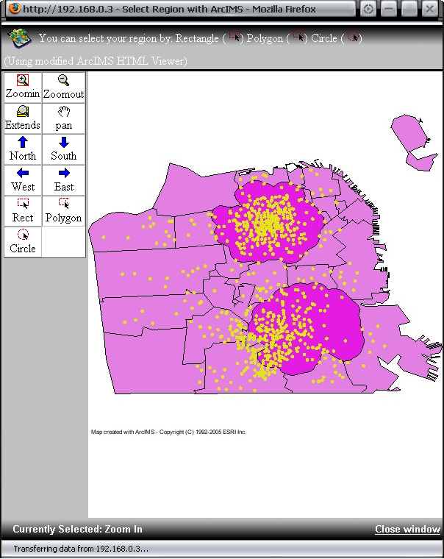
Figure 2 New region selection tool
This illustration shows a basic browser window that a user would see when they begin to select a zone. The three radio buttons on top dictate the region selection tool that ArcIMS will use (these radio buttons were chosen to allow the user to see which mode/tool is currently selected). The space in the middle of the browser is reserved for the ArcIMS graphical view itself, letting the user define their region based on the aforementioned selection tool. When the user is done selecting the region, they may click the “Append” button, to save their changes.

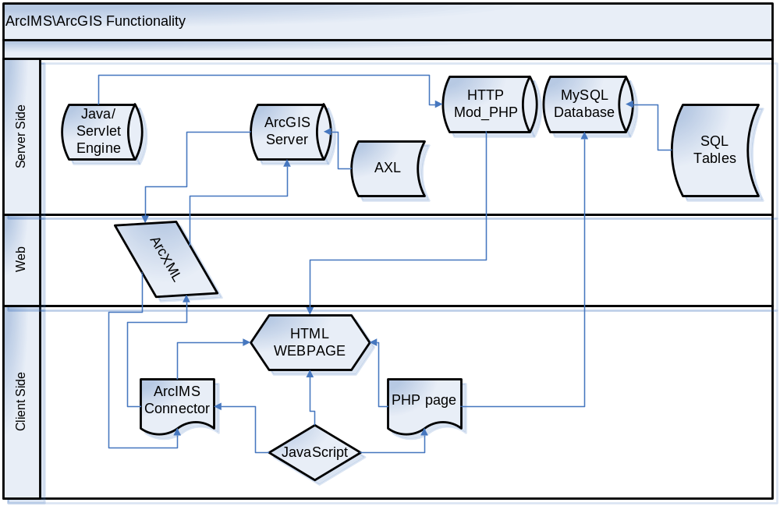
Figure 3 Solution and Information flow

Figure 3 shows the flow of information within the new region selection tool. The user’s browser loads the PHP page. Part of the page is static HTML and some JavaScript. The PHP script creates a connection to the SQL database in which the user records are stored. Once you determine your selection method, the PHP script connects you to the ArcIMS service. This service uses it own language, ArcXML, to contact the ArcGIS server, which subsequently displays your desired map.

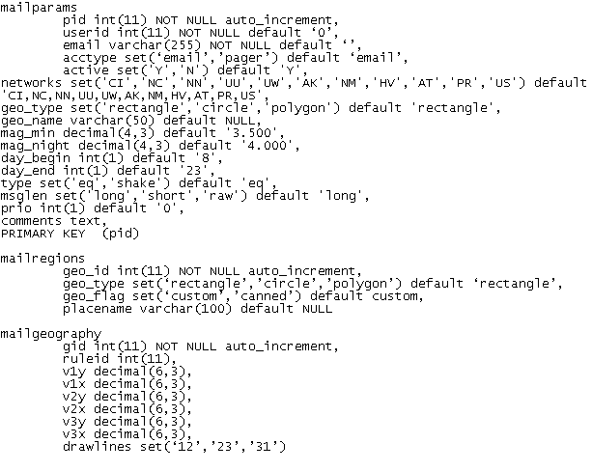
Figure 4 MySQL Database Structure

Figure 4 shows the exact layout of the MySQL database tables. The ENS PHP scripts take values specified by the user and store them in the database. The database is also used during the registration process.

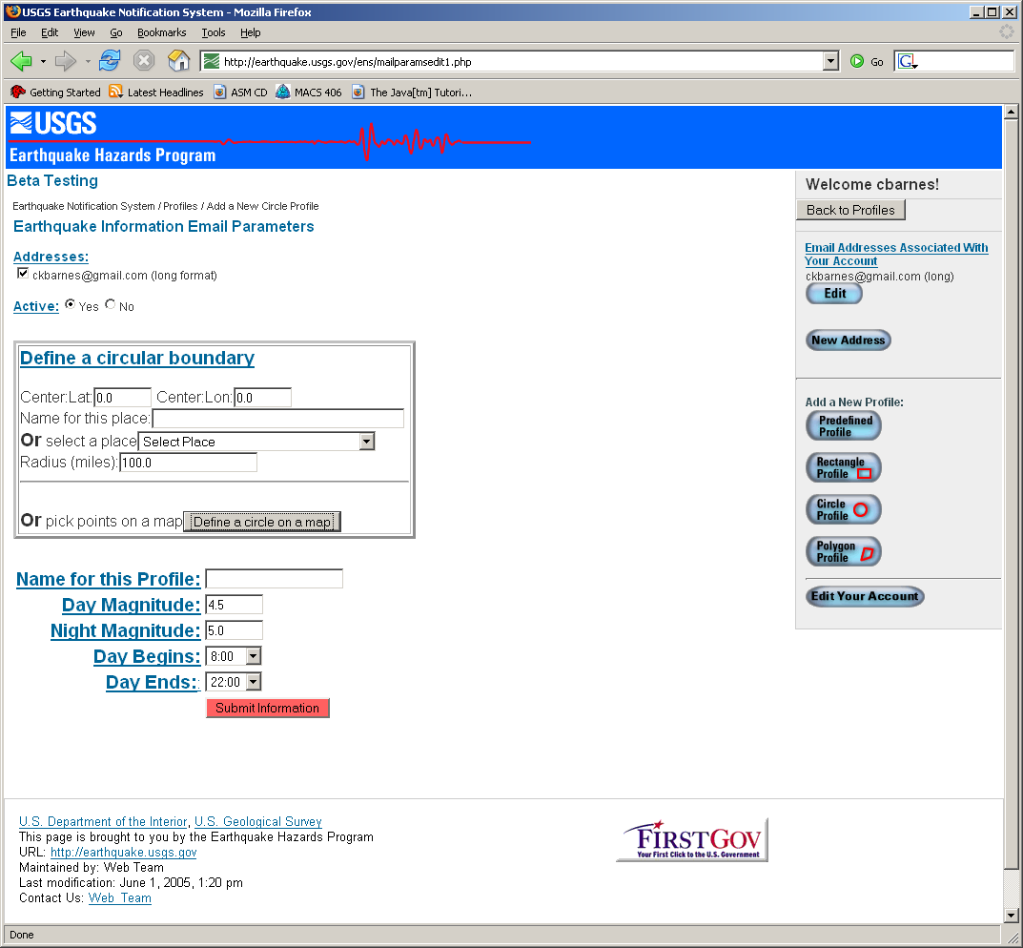
Figure 5 Main Page

Figure 5 shows the main ENS profile creation page for the Circle Profile. Once the user clicks “Submit Information,” the profile will be created and stored into the database.

3.2.4 Story Rationale
Although the use of ArcIMS has been justified, the implementation design setup has not. The original version of ENS had four tools the user could choose from: a predefined area, circle, rectangle, and polygon. The last three items have been moved to the new window with ArcIMS. This is done for several reasons. First, since we are only improving the user defined region selection tools, we move the buttons to guarantee mutual exclusion with the predefined areas. Secondly, each tool was originally given its own window to use. Moving them to one window minimizes the places that the user must visit. If a user were to dislike a current region selection, they can simply change tools instead of closing a window and waiting for another to load.

4.0 Implementation and Results

4.1 Implementation
In order to accomplish our tasks, we set up a test server, where all the necessary services were installed. As soon as this was done, we used ArcGIS’s web design system to implement an HTML ArcIMS viewer. It should be noted that although this viewer uses HTML, it is also a complex conglomerate of two other systems (HTML means, in this context, that the viewer does not require the use of a Java browser plug-in). In order for the ArcGIS servers to communicate with the viewer, a Java Server Page (JSP or servlet) is used. This page provides the communication backbone for the server/client interactions, as well as supplying a container in which the map itself can be displayed. Another aspect of the viewer is that is uses customizable JavaScript files to not only configure the viewer but to also define viewer functions. Additionally, all the ArcXML requests (to actually communicate with the server) are first constructed by the JavaScript code, which they then pass on to the servlet, and vice versa.

Fortuitously, much of the functionality that this project required was already implemented. What remained was to alter the existing functionality to output map coordinates (the original purpose of the methods were to select a region, and display information about that region, or its contents). This was accomplished through editing the JavaScript files.

A requisite of this project was that our solution be able to interface with an SQL database. In order for this to occur, JavaScript was once again used. PHP is the language used to interact with the database. See (Figure 3) for a complex breakdown of information flow and system component interaction.

4.2 Results

4.2.1 Primary Goals- Region Selection System
As stated before, we were tasked with designing and implementing an improved region selection tool. The modified ArcIMS HTML viewer does just that.
It allows the user to easily select their region, using easily readable buttons (See Figure 2). It also decreases the overhead for selecting a region. In the original system, ENS needed to repeatedly reload jpg files in excess of 200 KB (~8 seconds load time on dial up). ArcIMS’s server/client system only needs to reload a 50 KB (~2 seconds).

The new tool must be able to interface with the existing SQL database. As stated before, we have modified the viewer to send an array of points to a PHP, which interfaces with the SQL database.

Since ArcIMS does not track user state, we fulfill the requirements put forth by United States law. Additionally, since our solution provides a web-based front-end, this maintains the ENS’s accessibility.

Unfortunately ArcIMS is not designed for the dynamic loading of maps, this has prevented us from implementing the desired thumbnails. This restriction also prevents the user from editing an existing region. ArcIMS can be tailored to this need, however it requires a considerable amount of time, and it could not of been completed within our time frame.

4.2.2 Secondary- UI/Functionality Review
An examination of Figure 5 (the current circular region selection tool) yields a few improvements that this team believes should be implemented.

The first recommendation from this team is to modify the “Define shape boundary box”. In its current implementation, the tools ask first for optional numerical input, and the button to invoke the graphical selection utility is below that. This may be confusing to some users who are unfamiliar with latitude/longitude coordinate representation.

Another recommendation is to add additional information to the labels. As an example, take the “Active” label from Figure 5. The meaning of the label is not readily apparent and a user would be forced to look at the help popup to understand if they should take action or not. As stated before, a user interface must reduce the number of places the client must go when accomplishing a task. Including supplementary text on some labels would reduce this problem.

5.0 Conclusions

5.1 Lessons Learned
In the course of designing and constructing the software, we have discovered several aspects in software development that have both negatively and positively influenced this project as a whole.

The importance of descriptive comments has become entirely too clear. As our team attempted to decipher the current ENS, we were faced with PHP scripts with 1000 lines of code or more. The number of comments per file decreased as the file increased in length.

The most harmful facet was the difficult installation of the ArcIMS/ArcGIS software on our test servers. Obtaining the proper registration and keys was time-consuming. This has taught us that when planning any software project, that special attention must be given to the actual setup and deployment of the development platform.

Additionally, as we progressed through this project, we found that many of the principles of extreme programming were tremendously valuable. One such principle was paired programming. Our team set up a TeamSpeak® server, allowing us to communicate with each other in real-time, over the Internet, from our homes. Furthermore, the production server was fitted with a VNC server. This let other members, again from their homes, watch code being developed by another team member, and if necessary, take control of the development computer to point out bugs, other solutions, etc.

5.2 Future Improvement/Extension
Although we have provided an improved region selection tool, there are several more portions of ArcIMS that can be further integrated into the ENS. With more time and more resources, the viewer can be extended to edit selected regions, not just generate them.

5.3 Other Options
In the event that ArcIMS proves too expensive or difficult to integrate, this team has compiled options for the USGS to take:

- A simple improvement to the current system is changing the quality of the base map images. This requires increasing the compression on the current image files, which would result in a faster load time of the images. Unfortunately, this would also result in a corresponding drop in image quality.

- A second option is to add layers to the images, simplifying the reloading of an image. Instead of downloading the entire basemap, the system would only need to load a transparent layer with the outlines of the selection drawn on that layer. This can be accomplished by setting the basemap as a background image-using html, and loading an altered transparent image overlaid on the basemap image. Alternately, using JavaScript, one could use a multilayered "GIF", and create new layers.

6.0 Glossary

ArcIMS: A software similar to Mapquest (tm), that allows interactive manipulation of graphical data. In our case, geographical information.
ENS: Earthquake notification system.
HTML: HyperText Markup Language. A language used to express webpages.
JSP: Java Server Pages.
PHP: A server-side scripting language, facilitating access to databases and dynamic content.
USGS: United States Geological Survey.

7.0 References

Sources for Requirements Documentation:
USGS current ENS website: http://earthquake.usgs.gov/ens/index.php
USGS Project contacts: David Wald(wald@usgs.gov),Lisa Wald(lisa@usgs.gov)
ENS current implementation documentation

Design guidelines recommended by Alan Cooper & Robert Reiman in “About Face 2.0”
As an additional note, during testing of the Java-based viewers, it was discovered that they were unable to run on some browsers, unless extensive, potentially unsafe modifications to the browsers settings were made.

