Final Report
CDE I and CDE II

Steven K. Brier
Abstract:

The Colorado Department of Education and the National Science Foundation has set up with Colorado School of Mines a continuing education program for middle school education and the proliferation of mathematics and science. One of the key components of the continuing education program is a group of workshops designed for middle school teachers to advance and enrich mathematics and science in a classroom environment. These workshops are called Colorado Department of Education (CDE) I and CDE II. CDE I is an initial course of instruction for middle school teachers. CDE II is being taught for the first time this summer as a continuation course to CDE I. The workshops are developed and taught by graduate students, the graduate fellows. This project will help the graduate fellows with the construction and instruction of CDE I and CDE II. Current lesson plans will be modified for CDE I to improve accuracy and presentation of content. New lesson plans will be created for CDE II. The primary goal is give the teachers new and exciting ways to teach mathematics and science.

Introduction and Requirements:

The K-12 outreach program is an ongoing grant between Colorado School of Mines; the National Science Foundation, grants EED-02300702 and DGE 0231611; and the Colorado Department of Education, from No Child Left Behind grant. The primary target of the programs developed over the past four years ahs been the instruction of middle school teachers. This instruction has been provided through a variety of summer workshops and graduate student intervention in classroom.
The Colorado Department of Education has set six main goals for students to achieve in mathematics, these goals are:
- Become mathematical problem solvers
- Learn to communicate mathematically
- Learn to reason mathematically
- Make mathematical connections
- Become confidant in their mathematical abilities and
- To learn the value of mathematics
From these ideal that have been created two summer workshop programs have been created, the workshops are called Colorado Department of Education (CDE) I and CDE II. The workshops are to present new and exciting ways to middle school teachers to teach science and mathematics, so that the skills learned in the workshops may be taken back and applied in the classroom. To help facilitate the application of instruction in the classroom lesson plans will be given to the teachers attending the workshops so that new ideas may augment their teaching methods. The teachers will take a standardize CDE test at the beginning and end of the workshop to help collect data on methods that are working in instruction of the material. Further studies will be conducted regarding the improvements of CSAP scores in classrooms with teachers who have attended the workshop and teachers who have not.
The field session team (FST) will consist of one senior student from the Department of Mathematical and Computer Science and one graduate student, i.e. graduate fellow. The FST will provide review and revision to current lesson plans that have already been created for CDE I. The review and revision process is to incorporate lessons learned from past instruction and feedback from past attendees to improve the learning environment. This process will consist of updating lesson plans for content and grammar to ensure better alignment with the standards put forth by the Colorado Department of Education. Activities to be presented will be modified and created as needed to better instruct the student in the classroom. The lesson plans to be reviewed and revised include:
- Introduction to Graphing
- Introduction to Simple Machines, Mechanical Advantage, and Motion
- Introduction to Microsoft Excel
- Introduction to Waves, Sound, and Light
As a final check all lesson plans will be reviewed by other graduate fellows to check for accuracy of content and proper formatting.
For CDE II the FST will develop new lesson plans to be taught at the newly created CDE II workshop. CDE II is a follow-up workshop for teachers who have already taken CDE I. This will allow further more advanced instruction. The lesson plans will follow the same format as the lesson plans from CDE I to provide a consistent base of instruction. The lesson plans to be created include:
- Introduction to Graphing Calculators with Emphasis on Plotting Equations and Min/Max
- Introduction to Graphing Calculators with Emphasis on Plot Points and Intersections
- I Introduction to Graphing Calculators with Emphasis on Statistics and Solver Functions
- Introduction to Simple Mathematical Proofs
As mentioned above there will be a review and revision process conducted by other graduate fellows.
The FST will provide instruction at CDE I on the Introduction to Simple Machines, Mechanical Advantage, and Motion; and Introduction to Microsoft Excel lessons.

Design:

In the project there are two major products to be developed. The two products are:
- Revise and review existing lesson plans for CDE I
- Create lesson plans for CDE II
The products must provide a clear base of instruction so that a teacher may pick up the lesson plan and utilize them in a classroom environment. To help insure quality and standardization the lesson plans will follow the template, see Appendix A, created by Dr. Moskal and Dr. Skokan. All lesson plans are created with the standards outlined by the Colorado Model Content Standards for Mathematics, Appendix B, and Colorado Model Content Standards for Science, Appendix C, utilized as guidelines.
Revision consists of a thorough proofreading of a digital version of an activity created for previous instruction. This proofreading focuses on content and grammar. It may include the addition of small amount of new information. This will involve updates to the formatting, dates, and layout. There will be updates to content so that the information presented will best help the teachers to pass the standardized test administered at the end of the workshop. Revised lesson plans are included in Appendix D, Appendix E, Appendix F, and Appendix G.
Review involves a final proofreading focusing on grammar, flow, and any new content that was added during a revision to the lesson plans. If updates to material were not made yet to match the standardized test, updates will be conducted at this time.
Creation involves the development of an activity and discussion from scratch. Typically this will involve the brainstorming of ideas so that all areas of a topic can be covered. The new lesson plans that are created are included in Appendix H and Appendix I.

Appendix A

Subject
Put A Subject Title Here

Unit
Elements, Mixtures And Compounds

Activity Name
The Name Of This Lesson Is Really Descriptive

Activity Objective
Put into words what should be carried out in a brief sentence or tw o. Why would someone ever do this experiment?

Standards
The following Colorado standards addressed by this activity can be identified as:
- Math Standard 7.2
- Science Standard 7.4

Benchmarks
The following Colorado benchmarks addressed by this activity can be identified as:
- Benchmark 5
- Benchmark 6

Knowledge
Describe any necessary knowledge or experience that may be useful for completing this activity.

Skills
Discuss if you think you need skills for this project

Relevance
How is this project relevant?

Assessment Tasks
How do you plan to assess these this activity? Will the experiment illustrate what you want?
(Example)
Students will demonstrate their knowledge through notebooks, graphs, and fancy things like this.

Scoring Criteria
The following rubric should be implemented to help assess and measure the success of the students:
Objectives | Low Performance | Below Average | At or Above Average | Exemplary Performance
Students are able to demonstrate something (Example) | 0 points  Nothing is shown (Example) | 1 point  Something is shown (Example) | 2 points  Calculations are shown (Example) | 3 points  Hand derivations and history (Example)

Pre-Assessment
Define methods for performing a pre assessment

Necessary Materials
The following is an outline of necessary materials for this activity:
Item Description | Quantity per  TEAM | Quantity per CLASSROOM (8 teams)
Rulers | 1 | 8
Pencils | 2 | 16
250 ml Flask | 1 | 8

Instruction
Document how you plan on performing this activity. Discuss the procedures, important notes, etc.

Potential Accommodations
This can be for gifted, ESL, slow, fast kids…

Follow-up
Discuss what can be done to further the learning.

References
Cite all references here. Don’t just put URLs.

(Example)
Rubric Builder
A useful website dedicated to building scoring rubrics.
Available at: http://www.landmark-project.com/classweb/tools/rubric_builder.php

Appendix B and Appendix C I’m not including here because they are big adobe files.

Appendix D

UNIT 2 (Math)

Changes in Matter (Physical and Chemical) and Energy

SUBJECT

Graphing (Scatter Plots)

Algebraic Equations

Unit Conversions: Mass, Volume, Temperature, Energy

GOAL
This unit is designed to reinforce students’ math skills and knowledge in chemistry and illustrate how these skills can be applied. Specifically, we will plot graphs of temperature vs. time for endothermic/exothermic reactions and calculate the transferred energy.

OBJECTIVES
From this unit, students should be able to
- Plot a graph (scatter plot) manually
- Interpret data collected from their experiments from the graph (i.e. data trend)
- Know how to do simple linear interpolation if data has linear relationship
- Make future predictions of the experiments based on collected data
- Know common metric (SI) and English units for mass, volume, temperature, and energy

STANDARDS
The following Colorado math standards addressed by this activity can be identified as:
- 6th Grade
  - MA 6.2, especially 6.2.2 and 6.2.4
  - MA 6.5, especially 6.5.3
- 7th Grade
  - MA 7.2, especially 7.2.3-7.2.4
  - MA 7.3, especially 7.3.1-7.3.2
  - MA 7.5, especially 7.5.3
- 8th Grade
  - MA 8.2, especially 8.2.3-8.2.4
  - MA 8.5, especially 8.5.3

KNOWLEDGE AND SKILLS
The students should have background in
- Simple arithmetic or math facts (addition, subtraction, multiplication, division)
- Decimal numbers, rounding decimal numbers to certain places
- Equations with one variable
- Simple scatter plots

NOTE: for this unit, calculators are allowed; students don’t have to know arithmetic with decimal numbers.

Assessment Tasks
- Pre-Assessment: Students background can be evaluated through a short warm-up exercise about graphs. The given pre-assessment is taken from the on-line math Praxis practice test.
- Post-Assessment: Students will demonstrate their skills of graphing and their understanding of heat equations through exercise problems.

Scoring Criteria
The following rubric should be implemented to help assess and measure the success of the students:

 | Un-proficiency | Proficiency | Satisfactory | Above Satisfactory
Pre-Assessment | N/A | 1 correct answer | 2 correct answers | N/A
Graphing Skills | * Have no idea how to plot a graph | * Attempt to plot the graph but incomplete layout  * Attempt to do linear interpolation | * Plot the graph but the incomplete layout  * Can do linear interpolation (80-90% correct) | * Plot a complete graph  * Correct linear interpolation
Transferred Energy Equations | * Don’t know what formula to use | * Attempt to apply the formula but lack knowledge about units | * Can use the formula and attempt to convert units | * Correct answer

POTENTIAL ACCOMMODATIONS
- For advanced students:
  - Offer extra-credit exercises
  - Recommend to help other students
- For un-proficient students:
  - Explain the concepts slowly
  - Start with simple and basic problems first
- For ESL (English as Second Language) students:
  - Give a vocabulary sheet with possible new terms

FOLLOW-UP
- Base-10 system
- Bar graph
- Histogram
- Time conversion

MATH CONCEPTS

- GRAPHING (Scatter Plots)

  - Basic Layout of A Graph

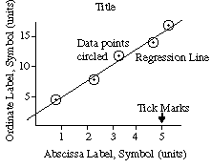

    - Title
The title of the graph should uniquely identify the graph and should be located on a clear space at the top of the graph.

Example:
(i) Good choices of titles:
“Variation of Temperature with Time when Salt Dissolved in Water”
“Variation of Displacement with Elapsed Time for a Freely Falling Ball”

(ii) Poor choices of titles:
“y vs. x”
“Temperature vs. Time”
“Data from Table 1”

    - Axes
The horizontal axis is commonly known as the x-axis (formally called abscissa) and the vertical axis is commonly known as the y-axis (formally called the ordinate). The x and the y axes intercept at the origin where the “x value” and the “y value” both equal zero.

Normally, the x-axis indicates the independent variable (the one over which you have control) and the y-axis indicates dependent variable (data you collect during the experiment). For example, to plot a graph showing how temperature changes with time when you dissolve salt in water, time should be along the x-axis and temperature should be along the x-axis.

      - Axes Labels
The axes should be labeled with words and with units clearly indicated. The words describe what is plotted, and perhaps its symbol. The units are generally in parentheses. An example would be “Time, t (min)” for the x-axis and “Temperature, T (ºC)” for the y-axis.

      - Tick Marks
Tick marks should be made on the axes for major divisions and subdivisions (see the above sample graph).

      - Scales
The scale should be chosen so that it is easy to read and it makes the data occupy more than half of the paper. Good choices of units to place next to major divisions on the paper are multiples of 1, 2, and 5. This makes reading subdivisions easy. Avoid other numbers, especially 3, 6, 7, 9, since you will likely make errors in plotting and in reading values from the graph.

NOTE: Avoid labeling “Position in meters (x 10⁻³)” since this confuses the reader; it is not clear whether the values are multiplied by 10⁻³ before or after plotting. Instead, it is better to state or use standard prefixes like kilo or milli: “Position (mm)”

    - Plotting
Data should be plotted as precisely as possible, with a sharp pencil and a small dot. In order to see the dot after it has been plotted, put a circle or box around the dot (see the above sample graph). If there are more than one set of data on the same axes (i.e. for data of different groups or data of a group that does the experiment more than once), use a circle for the first data set, a box for the second data set, etc. and make sure to label (i.e. circle is for group A, box is for group B, etc.)

  - Interpretation and Analysis
    - Data trend
The graph makes it easier to observe how the “y values” depends on the “x values”. Looking at the graph, students should be able to make simple observations such as “y values” increase as “x values” increase, “y values” decrease as “x values” increase, “y values” stay the same, “y values” first increase/decrease and then stay the same, etc.

For deeper analysis, this unit focuses on linear relationships since energy is linear to change of temperature.

    - Linear Interpolation
      - Observation
If the data appear to cluster around a straight line (see the above sample graph), it is reasonable to conclude, “there is a correlation or a linear relationship between the ‘x’ and the ‘y’ values.”

      - Interpolating Technique
The equation of a straight line is defined as

y = (slope) x + intercept

Hence, once slope and intercept are determined, this equation can be used to predict data of the experiment. This equation is called slope-intercept form. For example, for a given ‘x value’, the ‘y value’ should be close to (slope) x + intercept and for a given ‘y value’, the ‘x value’ should be close to 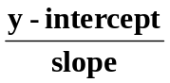

        - Slope determination
The simplest way to find the slope is to calculate the quotient of the difference between the last and the first “y values” to the difference between the last and the first “x values”:
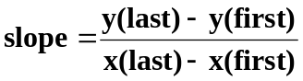

Positive slope indicates a “proportional relation”. For example if an “x value” increases by 5 units, a “y value” will increase about 5 units. If a line has a positive slope, it goes from the bottom left of the graph to the top right of the graph.

Negative slope indicates an “inversely proportional relation”. For example if an “x value” increases by 5 units, a “y value” will decrease about 5 units. If a line has a negative slope, it goes from the top left of the graph to the bottom right of the graph.

Mean, μ, is equal to: add all values in the list and divide by the number of values. Ex. Values = {3,5,7} Number of Values = 3. μ = 5.

A more precise way to find the slope is to divide the graph into smaller sections and use the above method to find the slope for each section; the mean of these “sub-slopes” can be considered as the slope of the entire graph.

NOTE: Slope does have units. For example, if the units of the “x values” are in second (sec) and the units of the “y values” are in meters (m), then the units of slope are meters per second (m/sec).

        - Intercept Determination
The simplest way to find the intercept is to draw a straight line that somewhat best fits the data (i.e. the line that has the most number of data points clustering around it), then extend the line until it crosses the y-axis. The “y value” where the line crosses the y-axis can be considered as intercept (also known as the y-intercept of the line). Intercept has the same unit as the “y values”.

NOTE: If the line goes directly through the origin, with intercepts of zero, and has a slope of one, we say that “y values” are directly proportional to “x values”.

    - Local Linear
If the data of the graph just shows linear relationship in a certain section, not the whole graph, then the data has local linear behavior. The above linear interpolation technique can be applied to just that section of the graph.

    - Relative Errors of Linear Interpolation
One simple way to analyze how precise the data fits the interpolated line (i.e. how good is the linear relationship of the data) is from the distance between the data point to the line, the smaller the distance, the better the interpolation. This distance is defined as the absolute value of the difference between the “y value” collected in the experiment and the “y value” determined by the equation of the interpolated line. Possible statistics can be the error range (i.e. the shortest distance or the smallest error and the longest distance or the largest error) and the mean error (i.e. the mean of all the distances).

- BASIC HEAT EQUATIONS
  - Formula
Mathematically, the amount of heat transferred during a reaction is commonly defined as
Q = c × m × ΔT

where Q is the amount of heat transferred (always positive), c is the specific heat of the substance, m is mass of the substance, and ΔT is the absolute value of the temperature change or the difference between the temperature after and before the reaction (ΔT=|T_{final}–T_{initial}|).

Because Q depends on the change of temperature, not the temperature itself, the unit of the temperature can be either in Celsius (ºC) or Kelvin (K) (see more in the Unit Conversions section for temperature). For example, if T_{initial} is 20ºC (293.15 K) and T_{final} is 65ºC (338.15 K), then ΔT equals 45ºC (45 K). The unit of specific heat c is usually J/(g ºC) or J/(g K), hence, the mass of substance m in the above equation must be in grams (g) and the unit of heat Q is in Joules (J).

NOTE: mass m is the product of density and volume (m = V × D where V is volume and D is density). Note that units of volume and density must agree, for example if the density is in gram per litter (g/L), the volume must be in liters (L). (see more in the Unit Conversions for mass and volume).

If the molar heat capacity of which unit is J/(mol ºC) or J/(mol K) is given instead of the specific heat, the heat Q can be calculated by

Q = c_{m} × n × ΔT

where c_{m} is the molar heat capacity and n is moles of the substance (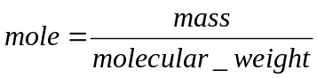)

In addition to the SI unit Joule for energy, scientists sometimes use calorie (cal). By definition, 1 calorie (cal) of heat is the amount of energy needed to raise 1 g of water by 1ºC. More specifically, 1 cal = 4.184 J (exactly).

NOTE: 1 Cal = 1 kcal = 10³ cal = 4.184 kJ where 1 kJ = 10³ J

  - Characterization
    - Endothermic Reactions
If the system gets colder after a reaction (temperature decreases T_{final} < T_{initial}), heat has flowed from the surroundings into the system (reaction absorbs energy). Such reactions are said to be endothermic.

    - Exothermic Reactions
If the system gets warmer or hotter after a reaction (temperature increases T_{final} > T_{initial}), heat has flowed from the system into the surroundings (reaction releases energy). Such reactions are said to be exothermic.

UNIT CONVERSIONS
- MASS
  - Common Metric (SI) Units

Prefix | Metric Ton | Kilogram (kg) | Hectogram (hg) | Dekagram (Dg) | Gram  (g) | Decigram (dg) | Centigram (cg) | Milligram (mg)
Meaning | 10⁶ | 10³ | 10² | 10¹ | 1 | 10⁻¹ | 10⁻² | 10⁻³

  - Common English Units
- 1 pound (lb) = 453.59 gram (g)
- 1 pound (lb) = 16 ounce (oz)
- 1 pound (lb) = 7,000 grain
- 1 pound (lb) = 256 dram (dr)
- 1 slug = 32.17 pounds (lb)
- 1 short hundred weight = 100 pounds (lb)
- 1 long hundred weight = 112 pounds (lb)
- 1 short ton = 2,000 pounds (lb)
- 1 long ton = 2,240 pounds (lb)

  - Examples
- Convert 57 g to kg.
ANS: 1 g = 10⁻³ kg
→ 57 g = 57 × 10⁻³ = 0.057 kg

- Convert 0.2 kg to mg.
ANS: 1 g = 10⁻³ kg = 10³ mg
→ 1 kg = 10⁶ mg
→ 0.2 kg = 0.2 × 10⁶ = 200,000 mg

- Convert 1.5 kg to lb. Round the result to the nearest thousandth place.
ANS: 1 lb = 453.59 g = 453.59 × 10⁻³ kg = 0.45359 kg
OR 0.45359 kg = 1 lb
→ 1.5 kg = 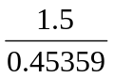 ≈ 3.307 lb

- VOLUME
  - Common Metric (SI) Units
    - Solid Volume

Prefix | Cubic Meter  (m³) | Cubic Decimeter  (dm³) | Cubic Centimeter  (cc) | Cubic Millimeter  (mm³)
Meaning | 1 | 10⁻³ | 10⁻⁶ | 10⁻⁹

    - Fluid or Gas Volume

Prefix | Liter (L)  OR  Cubic Decimeter (dm³) | Deciliter  (dL) | Centiliter  (cL) | Milliliter  (mL)
Meaning | 1 | 10⁻¹ | 10⁻² | 10⁻³

  - Common English Units
- 1 inch (in) = 2.54 centimeters (cm)
→ 1 cubic inch (in³) = 2.54³ cubic centimeters (cm³)
- 1 foot (ft) = 12 inches (in)
→ 1 cubic foot (ft³) = 12³ cubic inches (in³)
- 1 yard (yd) = 3 feet (ft)
→ 1 cubic yard (yd³) = 3³ cubic feet (ft³)
- 1 gallon (gal) = 231 cubic inches (in³)
- 1 gallon (gal) = 4 quart (qt)
- 1 gallon (gal) = 128 fluid ounce (fl oz)
- 1 quart (qt) = 32 fluid ounces (fl oz)
- 1 quart (qt) = 4 cups
- 1 tablespoon = 3 teaspoons
- 1 fluid ounce (fl oz) = 2 table spoons

NOTE:
Gallon here is U.S. gallon, which is different from imperial gallon.
Fluid ounce here is U.S. fluid ounce, which is different from imperial fluid ounce.

  - Examples
- Convert 2.3 m³ to mL³.
ANS: 2.3 m³ = 2.3 × 10³ dm³ = 2,300 dm³ = 2,300 L = 2,300 × 10³ mL
= 2,300,000 mL

- Convert 1 gal to L. Round the results to the nearest thousandth place.
ANS: 1 gal = 231 in³ = 231 × 2.54³ cm³ = 3785.412 cm³
= 3785.412 × 10⁻³ dm³
= 3.785 dm³ ≈ 3.785 L

- TEMPERATURE
  - Common Units
Celsius (ºC) is the most common temperature unit in the world, except for in the United States where Fahrenheit (ºF) is much more popular.

Kelvin (K) is another temperature unit that is mostly used in science since it begins at absolute zero, that is, it has no negative numbers.

Conversion rules:
- From Celsius to Fahrenheit: 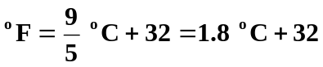
- From Fahrenheit to Celsius: 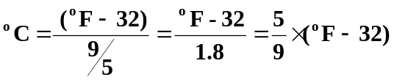
- From Celsius to Kelvin: K = ºC + 273.15

- From Kelvin to Celsius: ºC = K – 273.15

- From Kelvin to Fahrenheit: first, convert from Kelvin to Celsius, then convert from Celsius to Fahrenheit

- From Fahrenheit to Kelvin: first, convert from Fahrenheit to Celsius, the convert from Celsius to Kelvin

  - Examples
- Convert 100ºF to ºC. Round the result to the nearest hundredth place.
ANS: ºC = 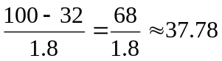 → 100ºF ≈ 37.78ºC

- Convert 300 K to ºF. Round the result to the nearest hundredth place.
ANS: ºC = 300 – 273.15 = 26.8 ºC
→ ºF = 1.8 × 26.85 + 32 = 80.33 → 300 K = 80.33ºF

PRE-ASSESSEMENT
QUESTIONS (Praxis Practice Test)

x | y
-4 | -2
-3 | 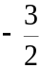
-2 | -1
-1 | 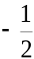
0 | 0

Which of the following is true about the data in the table above?
  - As x decreases, y increases
  - As x increases, y does not change
  - As x increases, y decreases
  - As x increases, y increases

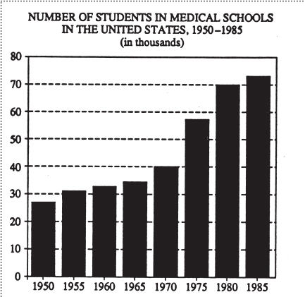
In how many of the years shown were there more than twice as many students in medical schools as there were in 1950?
  - None
  - One
  - Two
  - Three

PRE-ASSESSMENT
ANSWERS (Praxis Practice Test)

- The value of x increases from -4 to 0 while the value of y increases from -2 to 0. Thus, it can be seen that as x increases, y increases. The answer is d.

- There is information for eight different years in the bar graph. The vertical scale goes from 0 to 80,000. The zeros are left off the scale because the title tells you to read the numbers in thousands. To find the number of students in any one year, read the height of the corresponding bar off the left-hand scale and multiply that height by 1,000. The bar for 1950 has a height of about 27, so the number of students in 1950 was about 27,000. You have to find the number of years in which there were more than twice as many, that is, more than 54,000 students. To do this, count the number of bars that are higher than 54. These are the bars for 1975, 1980, and 1985. Thus, there were three years in which there were more than twice as many students as in 1950. The answer is d.

POST-ASSESSEMENT
QUESTIONS

- Consider the table below.
  - Plot a graph (by hand).
  - Discuss the graph (i.e., relationship between the “x” and the “y” values).
  - If possible, find a simple linear interpolation for the graph.

Time (sec) | Position (cm)
1 | 1.9
2 | 3.1
3 | 5.5
4 | 8.2
5 | 9.0
5 | 11.6
6 | 11.8
Table-Position of a snail as a function of time

- (Praxis Practice Test)
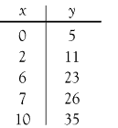

Which of the following formulas expresses the relationship between x and y in the table above?
  - y = x + 5
  - y = x + 6
  - y = 3x + 5
  - y = 4x – 1
  - y = 4x – 5

- What is the specific heat of silicon (Si) if it takes 192 J to raise the temperature of 45.0 g of Si by 6ºC?

POST-ASSESSEMENT
ANSWERS

- Consider the table below.
Time (sec) | Position (cm)
1 | 1.9
2 | 3.1
3 | 5.5
4 | 8.2
5 | 9.0
5 | 11.6
6 | 11.8

Table-Position of a snail as a function of time

  - Plot a graph (by hand)
ANS: The graph should look like the figure below

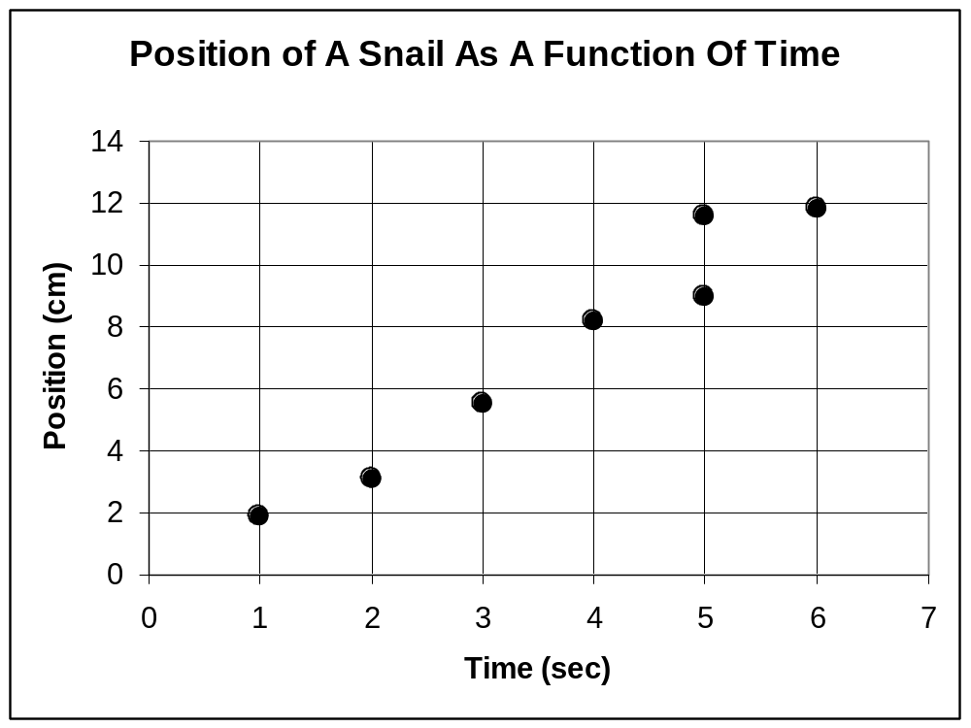

  - Discuss the graph (i.e., relationship between the “x” and the “y” values).
ANS:
The graph shows that position tends to have a linear relationship with time.

  - If possible, find a simple linear interpolation for the graph.
ANS:

position = (slope) (time) + intercept

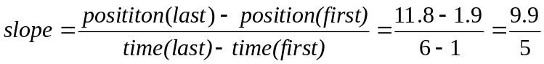 = 1.98 (cm/sec)

intercept: when extend the line closest to all data points, looks like the line will intercept the y-axis at around –0.5 cm. Hence, can have intercept = -0.5 cm.

→ One possible linear interpolation is
position (cm) = 1.98 (cm/sec) × time (sec) – 0.5 (cm)

Below is the linear interpolation done by MS Excel

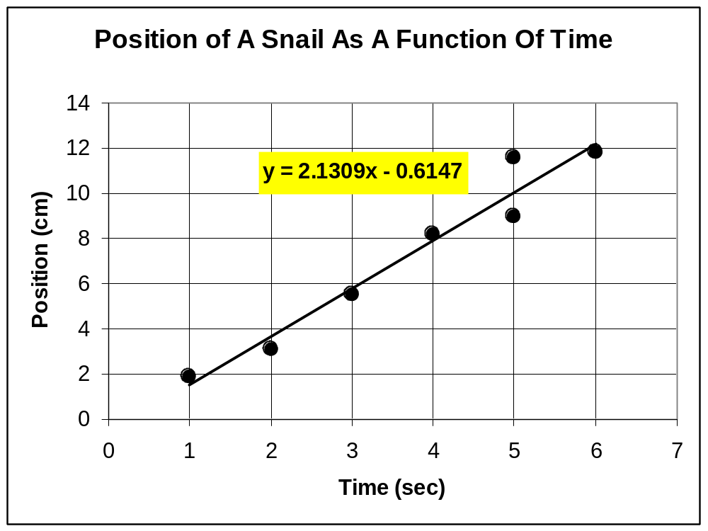

- (Praxis Practice Test)

Which of the following formulas expresses the relationship between x and y in the table above?
  - y = x + 5
  - y = x + 6
  - y = 3x + 5
  - y = 4x – 1
  - y = 4x – 5

ANS:
The correct formula must hold when each of the pairs of values from the table is substituted for x and y. The first choice holds for x = 0, y = 5, but not for x = 2, y = 11. The second, third, and last choices do not hold for x = 0. The third choice holds for all of the values given:
if x = 0, then y = 3(0) + 5 = 5,
if x = 2, then y = 3(2) + 5 = 11,
if x = 6, then y = 3(6) + 5 = 23, and so forth.

The answer is c.

Alternative way: y = (slope) x + intercept
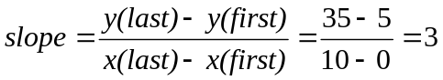
→ y = 3x + 5 OR The answer is c.
intercept = 5 (y-value when x = 0)

- What is the specific heat of silicon (Si) if it takes 192 J to raise the temperature of 45.0 g of Si by 6ºC?

ANS:
Q = c × m × ΔT → c = 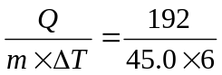= 0.71 J/(g ºC)

REFERENCES
[1] Chemistry, Second Edition, John McMurry and Robert C. Fay, Prentice-Hall Inc., 1998

[2] Fundamentals of Thermodynamics, 6th Ed, Borgnakke, Claus, Richard E. Sonntag, and Gordon J. Van Wylen, John Wiley and Sons, 2003

[3] http://www.rit.edu/~vwlsps/graphing/graphingpart1.html#layout, 5/12/04
(Graphing Section & Problem 1 of Post-Assessment)

[4] http://www.kbapps.com/conversion.html, 5/14/04
http://www.isotech.co.uk/convert.html, 5/19/04
(Unit Conversions)

[5] http://www.ets.org, 5/14/04
(Praxis Practice Tests)

Appendix E

UNIT 5 (Math)

Simple Machines

SUBJECT

Ratios and Proportions (Unit 1)

Algebraic Equations

Mass Versus Weight

GOAL
This unit is designed to reinforce students’ math skills and knowledge applied in simple machines.

OBJECTIVES
From this unit, students should be able to
- Identify the mechanical advantage of typical simple machines: levers, pulleys, wheels and axles, inclined planes, and wedges.
- Use the mechanical advantage to determine the desired force applied to the simple machines for certain loads.
- Understand simple concepts of mass and weight, including units.

STANDARDS
The following Colorado math standards addressed by this activity can be identified as:
- 6th Grade
  - MA 6.1, especially 6.1.5
  - MA 6.2, especially 6.2.2 and 6.2.4
  - MA 6.5, especially 6.5.3
  - MA 6.6, especially from 6.6.1 to 6.6.4
- 7th Grade
  - MA 7.1, especially 7.1.5
  - MA 7.2, especially 7.2.2-7.2.4
  - MA 7.3, especially 7.3.1-7.3.2
  - MA 7.5, especially 7.5.1 and 7.5.3
  - MA 7.6
- 8th Grade
  - MA 8.1, especially 8.1.1- 8.1.2
  - MA 8.2
  - MA 8.5, especially 8.5.1 and 8.5.3
  - MA 8.6

KNOWLEDGE AND SKILLS
The students should have background in
- Units 1 and 2

Assessment Tasks
- Pre-Assessment: Students background can be evaluated through a short warm-up exercise.
- Post-Assessment: Students will demonstrate their knowledge of simple machines through exercise problems.

Scoring Criteria
The following rubric should be implemented to help assess and measure the success of the students:

 | Un-proficiency | Proficiency | Satisfactory | Above Satisfactory
Pre-Assessment | N/A | 1 correct answer | 2 correct answers | N/A
Post-Assessment | ??? | ??? | ??? | ???

POTENTIAL ACCOMMODATIONS
- For advanced students:
  - Offer extra-credit exercises
  - Recommend to help other students
- For un-proficient students:
  - Explain the concepts slowly
  - Start with simple and basic problems first
- For ESL (English as Second Language) students:
  - Give a vocabulary sheet with possible new terms

MATH CONCEPTS

- RATIOS AND PROPORTIONS (covered in Unit 1)

- IMPORTANT MATH EQUATIONS OF SIMPLE MACHINES

  - Work
Scientifically speaking, work means using a force—anything that pushes or pulls, to move an object across a distance. Mathematically, work equals force times distance
Work (W) = force (F) × distance (d)
W = F*d

According to conservation of energy, for an ideal simple machine, work into a machine equals work out of a machine.
Work in = Work out + Work lost to friction

  - Law of Machines
    - Mechanical Advantage
Mechanical advantage is the unit less ratio of the force exerted by the machine to the force applied to the machine. Mechanical advantage is accomplished by a sacrifice of distance. For example, if work done F₁d₁ equals work done by F₂d₂, then 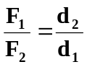. Thus, a small force multiplied by a large displacement is equivalent to a large force multiplied by a small displacement, and vice versa.

Ex.
Force in: 6 N. Distance moved: 2 m.
Work in = 6 * 2 = 12 Joules

Work out = 3*4 = 12 Joules
Force out: 3 N. Distance moved: 4 m.

Mechanical Advantage = F₁ / F₂ = 6 / 3 = 2

    - Efficiency of a Machine
Efficiency of a machine, η, is the ratio of the actual work done by the machine to the actual work done on the machine; the two quantities differing by the work done in overcoming friction.
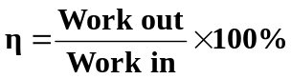

NOTE: For an ideal simple machine, η = 100% since friction equals 0 thus Work out equals Work in

  - Types of Simple Machines
    - Lever
A lever is a rigid bar that rotates around a fixed point called the fulcrum. It is often used to move heavy objects with less effort.

d₂
d₁
Load, F₁ (force of the object
desired to move)
Force, F₂
“With a big enough lever, you can
move the world.” (Archimedes)

NOTE: load is also known as weight, the gravitational force on the object.

weight = mass × g

where g is the acceleration due to gravity. On Earth, g = 9.8 m/sec² (see more in Mass vs. Weight Section)

    - Pulley
A simple pulley is a wheel with groove along its edge for holding a rope or cable wrapping around it. It makes it easier to lift heavy objects by increasing the distance over which the force is applied.
Load, F₁
Force, F₂
d₁
d₂

    - Wheel and Axle
The wheel and axle makes it easier to move heavy objects along. A wheel is a disc-shaped object of which the fundamental operation is to transfer linear motion (that is, going along) into rotary motion (that is, going around).
R_{axle}

R_{wheel}

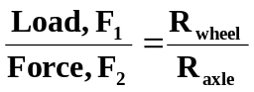

    - Inclined Plane
An inclined plane is a ramp that makes it easier to raise heavy objects to a higher elevation.
height, h
Force, F₂
Load, F₁
length, l
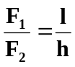

    - Wedge
A wedge is a modification of the inclined plane; it can either be composed of one or two inclined planes. Wedges are often used to separate objects.
l
Load, F₁
Force, F₂
h
DOUBLE WEDGE
l
Load, F₁
Force, F₂
h

SINGLE WEDGE

    - Screw
A screw is also a modified version of the inclined plane. A screw is an inclined plane wrapped around a cylinder to form a spiral, called threads. Screws are often used to hold objects. Analysis of a screw is much more complex than the previously mentioned machines.



MASS VERSUS WEIGHT
Mass
A measurement of the amount of matter
Measured by using a balance to compare a known amount of matter to an unknown amount of matter
Independent of location
Weight
A measurement of the pull of gravity on an object
Measured on a scale
weight = mass × g
where g is the acceleration due to gravity. In general, g = 9.8 m/sec² on Earth
Independent of location

- UNITS OF MASS (from UNIT 2)
  - Common Metric (SI) Units

Prefix | Metric Ton | Kilogram (kg) | Hectogram (hg) | Dekagram (Dg) | Gram  (g) | Decigram (dg) | Centigram (cg) | Milligram (mg)
Meaning | 10⁶ | 10³ | 10² | 10¹ | 1 | 10⁻¹ | 10⁻² | 10⁻³

  - Common English Units
- 1 pound (lb) = 453.59 gram (g)
- 1 pound (lb) = 16 ounce (oz)
- 1 pound (lb) = 7,000 grain
- 1 pound (lb) = 256 dram (dr)
- 1 slug = 32.17 pounds (lb)
- 1 short hundred weight = 100 pounds (lb)
- 1 long hundred weight = 112 pounds (lb)
- 1 short ton = 2,000 pounds (lb)
- 1 long ton = 2,240 pounds (lb)

- UNITS OF WEIGHT
  - Metric (SI) Units
On Earth, a 1 kg object has a weight of 9.8 N (Newton).
NOTE: 1 kN (kiloNewton) = 10³ N

  - English Units
- 1 dyne = 10⁻⁵ N

- By definition, 1 lb (weight) = (1 slug)(1 ft/sec²)

- 1 ft = 12 in = 12 × 2.54 cm = 30.48 cm = 0.3048 m
→ 1 ft/sec² = 0.3048 m/sec²
→ 9.80 m/sec² = 9.8 ÷ 0.3048 = 32.15 ft/sec²
→ the mass of 1 slug weighs 32.174 lb

- 1 slug = 32.17 lb = 32.17 × 0.45359 kg = 14.59 kg
→ the mass of 1 slug weighs 14.59 × 9.8 N = 142.98 N

→ 1 lb (weight) = 142.98 ÷ 32.174 N = 4.44 N

PRE-ASSESSEMENT
QUESTIONS (Praxis Practice Test)

- (Not a Praxis Practice Test) "Work equals force times distance" can be written
  - W = F x D
  - W = F / D
  - W = F – D
  - W = F + D

- If a:b = 2:3 and b:c = 6:7, then a:b:c equals
  - 3:4:5
  - 4:6:7
  - 1:2:3
  - 5:6:7

PRE-ASSESSMENT
ANSWERS (Praxis Practice Test)

- A
- B
            - POST-ASSESSEMENT
QUESTIONS

- A chain hoist lifts a 1 ton load (2000 lb) by the application of a 20 lb force on the loop of the chain. What is the actual mechanical advantage of this machine?

- A jack lifts an 800 lb load 6 in when a force of 50 lb is applied to the end of the 2 ft handle. What is the actual mechanical advantage of the jack?

- In splitting a tree with a wedge whose taper is 1 in each 6 in of length, what splitting force is applied to a log by a 50 lb (weight) hammer blow upon the wedge?

- If a 6 ft bar is used by a person to lift a 150 lb (weight) rock and a fulcrum can be located 1 ft from the rock end of the bar, what minimum force need be applied to the bar by the person, and where should it be applied?

- (Advanced) By the use of an inclined ramp whose rise is 3 ft in 10 ft along the incline, a 200 lb (weight) chest is dragged from a basement to the first floor of a building whose floors are 9 ft apart. What minimum force is required? Assuming an efficiency of 50%, what force would be required?

POST-ASSESSEMENT
ANSWERS

- A chain hoist lifts a 1 ton load (2000 lb) by the application of a 20 lb force on the loop of the chain. What is the actual mechanical advantage of this machine?
1 ton or
2000 lbs
20 lbs
Actual Mechanical Advantage = 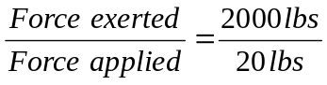= 100

- A jack lifts an 800 lb load 6 in when a force of 50 lb is applied to the end of the 2 ft handle. What is the actual mechanical advantage of the jack?

Actual Mechanical Advantage = 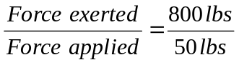= 16
800 lbs
50 lbs
2 ft
6 in

- In splitting a tree with a wedge whose taper is 1 in each 6 in of length, what splitting force is applied to a log by a 50 lb (weight) hammer blow upon the wedge?


50 lbs
Splitting force equals the forces exerted on the tree by the incline plane.

Splitting force = 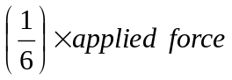
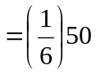= 8.33 lbs

- If a 6 ft bar is used by a person to lift a 150 lb (weight) rock and a fulcrum can be located 1 ft from the rock end of the bar, what minimum force needs be applied to the bar by the person, and where should it be applied?

30 lb (force) and should be applied at opposite end with fulcrum 1 foot from rock.

150 lb (Force due to rock) * 1 foot = 30 lb (Force applied) * 5 feet (remaining part of the rod)

- (Advanced) By the use of an inclined ramp whose rise is 3 ft in 10 ft along the incline, a 200 lb (weight) chest is dragged from a basement to the first floor of a building whose floors are 9 ft apart. What minimum force is required? Assuming an efficiency of 50%, what force would be required?

REFERENCES
[1] http://kosmoi.com/Science/Physics/Machine/, 5/16/04
http://www.uark.edu/depts/aeedhp/agscience/simpmach.htm, 5/16/04
(simple machines)

[2] http://www.kbapps.com/conversion.html, 5/14/04
(Unit Conversions)

[3] http://teachmathnet.tripod.com/sampletest.html, 5/16/04
(Pre-assessment, Problem 2)
http://www.ets.org, 5/14/04
http://www.ets.org/praxis/taags/0730index.html
(Praxis Practice Tests)

[4] http://www.harcourtschool.com/glossary/math2/define/gr4/protractor4.html, 5/14/04
http://www.mathresources.com/products/tools/interactive/protractor.htm, 5/14/04 (protractor)

Appendix F

UNIT # (Math)

Excel

SUBJECT

Bar Graph

Pie Chart

Cylinder Graph

Line Graph

GOAL
This unit is designed to reinforce students’ math skills and knowledge applied in simple graphs, and graphical representations. Specifically multiple graphs will be created with Excel to help provide visual instruction.

OBJECTIVES
From this unit, students should be able to
- Create a bar graph
- Create a line graph
- Create a pie chart
- Create a cylinder graph

STANDARDS
The following Colorado math standards addressed by this activity can be identified as:
- 6th Grade
- 7th Grade
- 8th Grade

KNOWLEDGE AND SKILLS
The students should have background in
- Statistics
- Tables
- Unit 2 Basic Graphs
- Basic entering of data into Excel

POTENTIAL ACCOMMODATIONS
- For advanced students:
  - Offer extra-credit exercises
  - Recommend to help other students
- For un-proficient students:
  - Explain the concepts slowly
  - Start with simple and basic problems first
- For ESL (English as Second Language) students:
  - Give a vocabulary sheet with possible new terms

MATH CONCEPTS

- Line Graph
  - A line graph is used to show a linear relation between data sets.

  - Create a Line Graph (Use Table A)
    - Open Excel
    - Type in given data set in two columns (label columns)
      - Standard Length (mm)
      - Fish Weight (grams)
    - Click on Chart Wizard
      - Click XY (Scatter), then click Next
      - Delete anything in data range
      - Click the Series Tab
      - Click Add
        - Click the Chart Button to the right of ‘x-values’ box
        - Using the mouse highlight all the values for standard lengths
        - Click again the Chart Button to the right of ‘x-values’ box
        - Click the Chart Button to the right of ‘y-values’ box
        - Using the mouse highlight all the values for fish weights
        - Click again the Chart Button to the right of ‘x-values’ box
      - Click Next
      - Enter the Title for the graph, the x-axis label, and y-axis label then click Next
      - Select to input the graph as a Sheet and then click Finish
    - Click the Chart Tab at the bottom of the page
      - Click on a data point, then right click while on the data point.
        - Select Add Trendline
        - Under the Type Tab, click on the linear graph
        - Click the Option Tab, and select ‘display equation’ and ‘display R²’

- Bar Graph
  - A bar graph is used to show changes in data sets

  - Create a Bar Graph (Use Table B
  - Open Excel
  - Type in given data set in three columns (label columns):
    - Time
    - Predicted Level (ft)
    - Observed Level (ft)
  - Enter a new column called Mean of Predicted Level (ft) and find the mean by:
    - Typing =average(B2:B25)
  - Enter a new column called Median of Predicted Level (ft) and find the median by:
    - Typing =median(B2:B25)
  - Enter a new column called Mode of Predicted Level (ft) and find the mode by:
    - Typing =mode(B2:B25)
  - Repeat steps 2.4-2.6 for the Observed Level
  - Click on Chart Wizard or Click Insert and select Chart
    - Select Column then click Next
    - Delete anything in data range
    - Click the Series Tab
    - Click Add
      - Enter Predicted Level in the name box
      - Click the Chart button of to the right of the values box
      - Using the mouse highlight all the values for Predicted Levels
      - Click the Chart button of to the right of the values box
      - Click the Chart button of to the right of the category box
      - Using the mouse highlight all the values for Time
      - Click the Chart button of to the right of the category box
    - Click Add again
      - Enter Observed Level in the name box
      - Click the Chart button of to the right of the name box
      - Using the mouse highlight all the values for Observed Levels
      - Click the Chart button of to the right of the values box
    - Click Next
    - Enter the Title for the graph, the x-axis label, and y-axis label then click Next
    - Select to input the graph as a Sheet and then click Finish

- Cylinder Graph
  - A cylinder graph serves the same purpose as a bar graph, but usually is more visually appealing and easier to read.

  - Create a cylinder graph
  - Open Excel
  - Type in given data set as shown in Table C (the ethnic groups are two cells merged together)
    - To merge two cells together, enter the data in the left-most cell. Using the mouse highlight the two cells to be merged. Click the merge cell button.
  - Click on Chart Wizard or click Insert and select Chart
    - Scroll down and click Cylinder then click Next
    - Delete anything in data range
    - Click the Series Tab
    - Click Add once
      - Enter ‘Men- Verbal’ in the Name box:
      - Click the Chart button to the right of the Values box
      - Hold control and using the mouse select all the men’s verbal scores
      - Click the Chart button to the right of the Values box
      - Repeat steps 3.5.4.1-3.5.4.4 for men’s quantitative and women’s verbal and quantitative
      - Click the Chart button to the right of the ‘Category (x) axis labels’ box
      - Hold control and using the mouse select all the ethnic groups
      - Click the Chart button to the right of the ‘Category (x) axis labels’ box
    - Click Next
    - Enter the Title for the graph, the x-axis label, and y-axis label then click Next
    - Select to input the graph as a Sheet and then click Finish

- Pie Chart
  - A pie chart is to show how resources are allocated. It shows visually the breakdown of resources by percent, such that the percents add up to 100%

  - Creating a Pie Chart
  - Open Excel
  - Type in given data set in two columns (label columns):
    - Category
    - Amount
  - Using the mouse highlight ‘Amount’ column then right click and go to Format Cells
    - Click the Number tab then click currency
    - Click OK
  - Click on Chart Wizard or click on Insert and select Chart
    - Select Pie then click Next
    - Delete anything in data range
    - Click the Series Tab
    - Click Add once
      - Click the Chart button to the right of the Values box
      - Using the mouse highlight all the values in the Amount column
      - Click the Chart button to the right of the values box
      - Click the Chart button to the right of the category labels box
      - Using the mouse highlight all the names under the Category column
      - Click the Chart button to the right of the category labels box
    - Next
    - Enter the Title for the graph, the x-axis label, and y-axis label then click Next
    - Select to input the graph as a Sheet and then click Finish
TABLE A

Fish in the South Platte River Basin
(taken 1993-1995)
http://co.water.usgs.gov/nawqa/splt/datarep/biosites/rawdata/all_fish.rdb.nawqa

Standard Length (mm) | Individual Weight (grams)
115 | 100
134 | 115
141 | 120
80 | 67
147 | 125
145 | 123
145 | 123
165 | 142
146 | 123
143 | 122
137 | 119
143 | 123
139 | 116
82 | 70
65 | 55
83 | 71
101 | 88
82 | 70
78 | 68
74 | 64
98 | 87
62 | 51
54 | 44

TABLE B

Water Level in Anchorage, Alaska
(taken July 25, 2004)
http://tidesonline.nos.noaa.gov/monitor.html

Time | Predicted  Level (ft) | Observed  Level (ft)
00:00 | 27.33 | 27.41
01:00 | 27.77 | 28.70
02:00 | 26.36 | 27.08
03:00 | 22.93 | 23.10
04:00 | 18.07 | 17.64
05:00 | 12.83 | 12.80
06:00 | 8.49 | 8.56
07:00 | 5.82 | 4.69
08:00 | 4.67 | 2.20
09:00 | 5.88 | 5.57
10:00 | 10.63 | 12.17
11:00 | 16.80 | 17.58
12:00 | 21.14 | 21.61
13:00 | 23.38 | 24.20
14:00 | 24.16 | 25.01
15:00 | 22.86 | 23.29
16:00 | 19.43 | 19.50
17:00 | 14.86 | 14.46
18:00 | 10.53 | 10.23
19:00 | 7.84 | 6.88
20:00 | 6.98 | 5.17
21:00 | 8.03 | 9.19
22:00 | 12.29 | 15.16
23:00 | 18.97 | 20.44

TABLE C

Average Graduate Record Examination
(GRE) Scores for 2001-2002
http://ftp.ets.org/pub/gre/994950.pdf

 | American Indian |  | Asian/Pacific |  | Black/African |  | Mexican American
 | Verbal | Quantitative | Verbal | Quantitative | Verbal | Quantitative | Verbal | Quantitative
Men | 473 | 540 | 490 | 671 | 401 | 458 | 442 | 530
Women | 443 | 472 | 484 | 599 | 391 | 413 | 420 | 459
 | Puerto Rican |  | Other Hispanic |  | White |  | Other
 | Verbal | Quantitative | Verbal | Quantitative | Verbal | Quantitative | Verbal | Quantitative
Men | 419 | 516 | 459 | 550 | 512 | 603 | 524 | 605
Women | 403 | 458 | 431 | 472 | 484 | 531 | 492 | 530

TABLE D

Colorado Resident Expenditures for CSM per Semester- 2004
http://www.is.mines.edu/budget/Schedule%20of%20Tuition%20and%20Fees.htm

Category | Amount
Tuition | $2,850
Health Services | $45
Associated Students | $63
Athletic Fee | $47
Student Assistance Fee | $14.50
Technology Fee | $60
Student Services | $137

Appendix G

UNIT 5 (Math)

Waves

SUBJECT

Waves

Sound

Light

GOAL
This unit is designed to reinforce students’ math skills and knowledge in physics and illustrate how these skills are applied. Specifically we will provide instruction in basic wave equations and properties of various forms of waves..

OBJECTIVES
From this unit, students should be able to
- Identify basic wave concepts
- Know how to add waves together

STANDARDS
The following Colorado math standards addressed by this activity can be identified as:
- 6th Grade
- 7th Grade
- 8th Grade

KNOWLEDGE AND SKILLS
The students should have background in
- Basic Algebra
- Trigonometry
- Equations with one variable

Assessment Tasks
- Pre-Assessment: Students background can be evaluated through a short warm-up exercise.
- Post-Assessment: Students will demonstrate their knowledge of simple machines through exercise problems.

Scoring Criteria
The following rubric should be implemented to help assess and measure the success of the students:

 | Un-proficiency | Proficiency | Satisfactory | Above Satisfactory
Pre-Assessment | N/A | 1 correct answer | 2 correct answers | N/A
Post-Assessment | ??? | ??? | ??? | ???

POTENTIAL ACCOMMODATIONS
- For advanced students:
  - Offer extra-credit exercises
  - Recommend to help other students
- For un-proficient students:
  - Explain the concepts slowly
  - Start with simple and basic problems first
- For ESL (English as Second Language) students:
  - Give a vocabulary sheet with possible new terms

MATH CONCEPTS

- Waves
  - A wave is a “up and down” movement. Waves are commonly seen in mathematics in trigonometric functions. The sine function produces the standard math wave. Types of waves include:
    - Sound
A sound wave travels as vibrations in matter, e.g. air, water, solid objects. A chain of vibrating molecules pass along energy creating regions of high and low pressure. The end result is variations in pressure that is heard.

    - Light
Light is an electromagnetic wave. A light wave travels as rays though vibrating electric and magnetic fields. Light does not require a material to travel through.

    - Mechanical
A mechanical wave is (add).

- Parts of a Wave
  - The crest of a wave is the portion of the wave that is above the undisturbed level. The trough of a wave is the portion of the wave that is below the disturbed level.

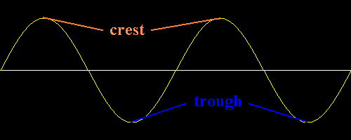
  - The amplitude of a wave is the displacement of medium from an undisturbed rest location to a disturbed excited location at a certain point along the wave. Amplitude can be either positive or negative. Typically we refer to amplitude as the maximum distance from the medium to the top of the crest.
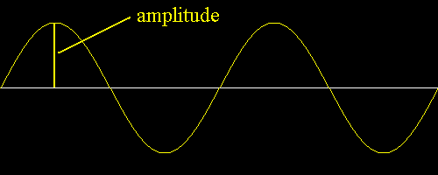
  - The node of a wave is the position along the wave where the amplitude is zero.
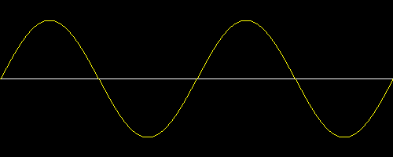
Node

  - Wavelength, designated by λ, is the distance between any two adjacent corresponding locations on a wave. Wavelength is typically measured from crest to crest, trough to trough or the start of a cycle to the next start of a cycle.
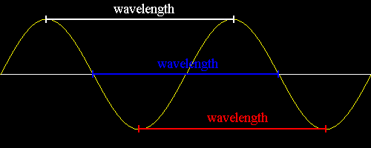
- Wave Speed
  - The frequency, f, of a wave is the number of waves in a time interval. Frequency is measured in number of cycles per second, this called the Hertz, Hz.
  - 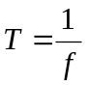The period, T, of a wave is the amount of time which it takes for a wave to fully pass a stationary point. Period is equal to the inverse of frequency and is measured in seconds.

  - Speed for a wave uses the usual definition for speed, distance/time. The speed of a wave is equal to the wavelength multiplied by the frequency.
c= λ*f
The speed of light = 300,000,000 m/s
The speed of sound = 300 m/s

Ex.
The human ear hears roughly from frequencies 20 Hz to 20,000 Hz. What are the corresponding wavelengths of the wave, use 300 m/s for the speed of sound.

300 m/s = λ *20 Hz
λ = 15 m

300 m/s = λ *20,000 Hz
λ = 0.015 m = 15 mm

- Interference
  - Phase relates to the position of the same point on two different waves. If the two points have the same amplitude the waves at that point are in phase. If the two points have different amplitudes the waves at that point are out of phase.
In Phase
Out of Phase

  - Superposition, or wave interference, occurs when two waves pass through each other. The amplitudes of the waves at corresponding points are added together. There are two types of interference either constructive interference or destructive interference.

    - Constructive interference occurs when either the crest of wave 1 passes through the crest of wave 2 or when the trough of wave 1 passes through the trough of wave 2.
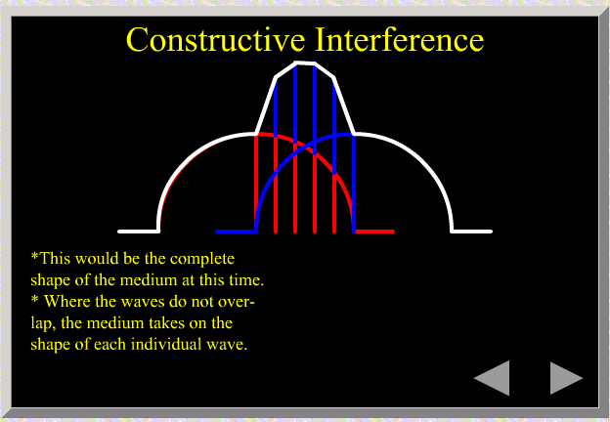
    - Destructive interference occurs when the crest of wave 1 passes through the trough of wave 2, or vice versa. This looks like subtraction due to the negative amplitude of wave 2.
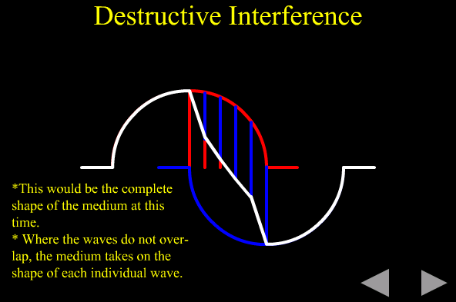

REFERENCES
[1]

Appendix H

Subject
Introduction to Graphing Calculator with Emphasis on Equations and Max/Min

Unit (Math)
- Introduction to Graphing
- Equations
- Max/Min

Activity Objective
To provide a familiarity with the TI-84 calculator. To help facilitate the understanding of graphing techniques and technology, specifically finding points of extrema.

Standards
Standard 2, specifically:
- analyzing functional relationships to explain how a change in one quantity results in a change in another (for example, how the area of a circle changes as the radius increases, or how a person’s height changes over time);
- distinguishing between linear* and nonlinear functions through informal investigations;
- solving simple linear equations in problem-solving situations using a variety of methods (informal, formal, graphical) and a variety of tools (physical materials, calculators, computers).
Standard 6, specifically:
- selecting and using appropriate methods for computing with commonly used fractions and decimals, percents, and integers in problem-solving situations from among mental arithmetic, estimation, paper-and-pencil, calculator, and computer methods, and determining whether the results are reasonable.

Knowledge and Skills
- Algebra
- CDE I Graphing Unit
- Mathematical Functions and Equations

Assessment Tasks
Proficiency in performing activity will help show familiarization with the graphing function and how functions look graphically. There will be no specific post-assessment for this lesson plan. The performance in the activity will constitute understanding of the instruction.

Scoring Criteria
The following rubric should be implemented to help assess and measure the success of the students:
Objectives | Low Performance | Below Average | At or Above Average | Exemplary Performance
Pre-Assessment | 0 points  No questions answered correctly | 1 point  1 question answered correctly | 2 points  Both questions answered correctly | 3 points  N/A

Pre-Assessment
Perform Pre-Assessment test

Necessary Materials

TI-83 or TI-84 calculators: 1 per person.

Potential Accommodations
This can be for gifted, ESL, slow, fast kids…
For students already familiar with the technology being instructed, encourage individual exploration, with how different graphs look like when minor algebra changes are made to functions; e.g. sin(x) -> sin(x+a), tan(x) -> cotan(x).

For students having difficulty with the subject, individual instruction may be necessary, also have the student draw the graph by hand first if it is a simple function, then have the student watch you perform the necessary steps.

Instruction

Equations
  - A mathematical equation, also called a function, is used to show a relation between a dependent variable and at least one independent variable. A dependent variable is sometimes referenced as the outcome variable. It represents the variable that is trying to be modeled, in basic algebra it is usually referred to as ‘y’. An independent variable is the variable that is being controlled. Independent variables modify the dependent variable, in basic algebra it is usually referred to as ‘x’. Graphing an equation helps to visually show the relation between the dependent and independent variable.

- Graphing Equations on a Calculator
  - Note--Some steps may be skipped sometimes.

  - Press MODE and set appropriate graph mode
    - For these exercises select Func for graphing mode
    - Float or 0123456789 decimal mode affects displayed coordinates
    - Radian or Degree affects interpretation of certain functions. (It is important to check that if you are working in degrees, Degree is selected; or if you are working in radians, Radian is selected. This is a common error).
    - Connected or Dot affects how a function is plotted
    - Sequential or Simul affects the order of graphing when there are two or functions or equations.
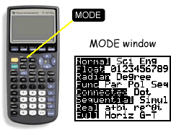

  - To display the equation editor press Y=
    - Use the up and down arrow keys to move to the equation which you wish to edit. If there is something already defined press CLEAR to erase the function.
    - Enter the equation which is being worked on. The independent variable is X. To enter X, press X,T, Θ, n key.

  - To select the equation(s) to be graphed, press Y= then using the arrow keys move the cursor to the equal sign of the corresponding equation.
    - Press ENTER. This will change the selection status. If it was previously selected it will deselect the equation. If it was previously not selected it will select the equation.

  - Press WINDOW to modify the viewing window of the coordinate plane to be graphed.
    - To change a window setting use the arrow keys to move the cursor to the variable to be changed. Enter a new value and press ENTER. (Note Xmin<Xmax and Ymin<Ymax).

  - To view the graph of an equation, press GRAPH.
    - With GRAPH pressed the cursor will be free-moving in the coordinate plan.

  - To follow values along a curve press TRACE.
    - TRACE allows for the cursor to follow the curve defined by Yn.
    - The coordinate values will be displayed at the bottom of the screen.
    - To move the cursor along the X values use the left and right arrow keys.
    - If more than 1 equation has been graphed use the up and down arrow keys to move from equation to equation.
    - Note—If the trace cursor is moved outside the screen window, the window will resize.
    - To determine the Y value at a certain X value, while at the trace screen type the X value to be evaluated and press ENTER.

- Extrema (Maximum or Minimum)
  - A point of extrema occurs where a critical point occurs, when the first derivative equals zero. A global minimum, or absolute minimum, occurs at x₀, when f(x₀)<=f(x) for all x. A global maximum, or absolute maximum, occurs at x₀, when f(x₀)>=f(x) for all x. A local minimum, or relative minimum, is the lowest point in a particular region of a graph. A local minimum occurs when the first derivative equals zero and is less then other f(x) in a region. A local maximum, or relative maximum, is the highest point in a particular region of a graph. A local maximum occurs when the first derivative equals zero and is greater then other f(x) in a region.

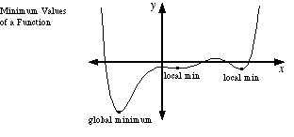

  - Find Max/Min while graphing.
    - Press 2nd CALC.
    - Select 3:minimum or 4:maximum from CALCULATE menu.
    - Set the left, minimum, bound and set the right, maximum bound.
    - Guess the minimum/maximum value.

- To exit from a menu press 2nd QUIT

Follow-up
Discuss what can be done to further the learning.

Reference
TI-83 Plus Reference Manual
http://www.prenhall.com/divisions/esm/app/graphing/ti83/Home_Screen/Menu_Keys/mode/mode.html
“Mathematics Teacher.” Vol 94 Number 2. Feb 2001
Pre-Assessment
- Graph y = sin(exp(-x)), -1<x<5
Which graph best represents y:

A.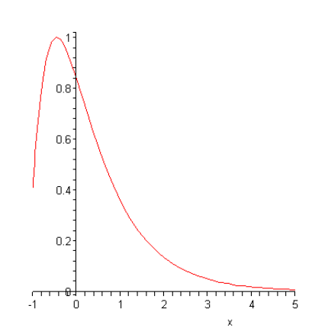B. 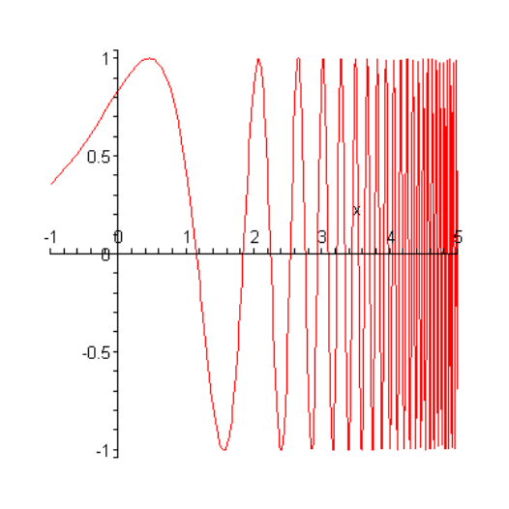

C.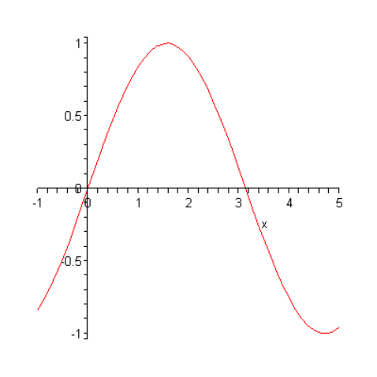D. 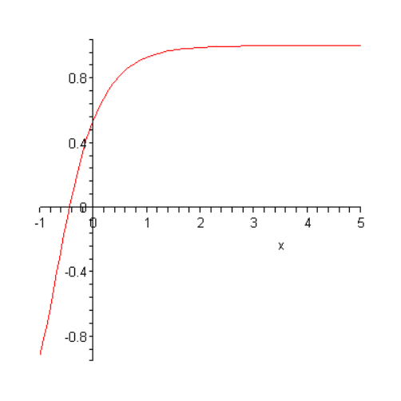

2. What are the extrema for :
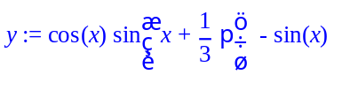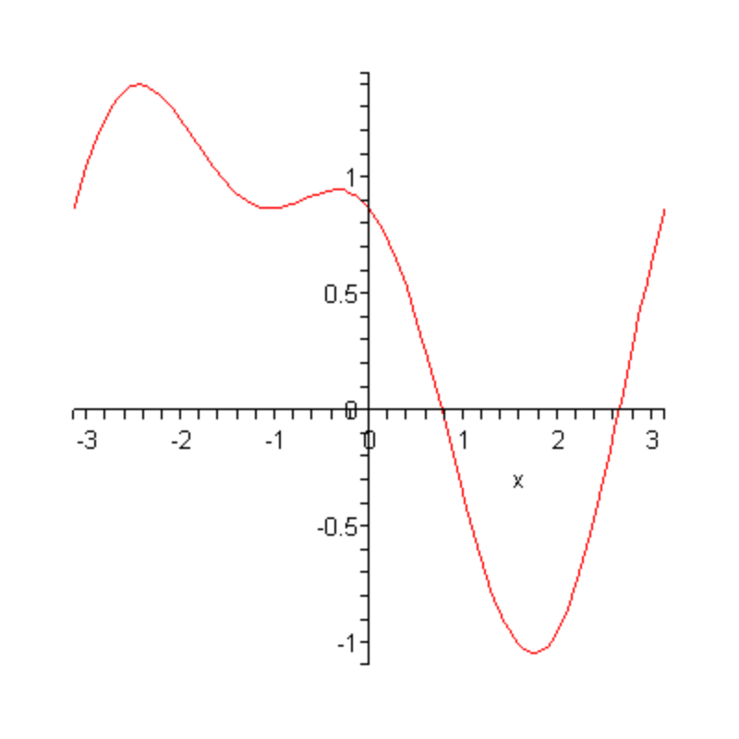

Greeting Card Activity
(From Mathematics Teacher Vol 94, Num 2 pg 106)

The goal of this activity is to provide familiarization with graphing tools and basic visualization of equations.

Making a Calculator Greeting: HAVE A HAPPY VALENTINE’S DAY!

[WINDOW]
Xmin=0
Xmax=12
Xscl=1
Ymin=0
Ymax=10
Yscl=1

[MODE]
Y1=(abs(2sin(x+π)) + 6)(x>= π)(x<=3 π)
Y2=(1.3abs(x-2 π) + 2) (x>= π)(x<=3 π)
Note: The >= and <= are under 2nd TEST

Return to Home Screen by Pressing 2nd QUIT
Text(4,10, “HAVE_A_HAPPY”)
Text(50,25, “VALENTINES_DAY”)

Note: Text is under 2nd DRAW
Note: To type letters, remember to lock the ALPHA key with 2nd A-LOCK

The calculator screen is divided into rows and columns with

(0,0) (0,94)

(57,0) (57,94)

Store the Greeting Card:
2nd DRAW press STO press StorePic Pic 1
Note: Pic1 is under VARS Picture.

Once the Valentines Card is created try and create new pictures and document the method to show others.

Appendix I

Subject
Introduction To Graphing Calculator With Emphasis On Plot Points And Intersections

Unit
- Plot Points
- Line Intersections

Activity Objective
To provide a familiarity with entering data into a TI-84 calculator and to help facilitate the understanding of using graphing techniques to solve algebraic problems.

Standards
Standard 2, specifically:
- reading and constructing displays of data using appropriate techniques (for example, line graphs, circle graphs, scatter plots*, box plots*, stem-and-leaf plots*) and appropriate technology;
- displaying and using measures of central tendency*, such as mean, median, and mode, and measures of variability*, such as range and quartiles; evaluating arguments that are based on statistical claims;
- formulating hypotheses, drawing conclusions, and making convincing arguments based on data analysis; determining probabilities through experiments or simulations;
- making predictions and comparing results using both experimental and theoretical probability drawn from real-world problems; and
- using counting strategies to determine all the possible outcomes from an experiment (for
- example, the number of ways students can line up to have their picture taken).

Knowledge and Skills
- Algebraic Manipulation
- CDE I Graphing Unit
- Graphing I CDE 2

Assessment Tasks
Assessment will be successful completion the different activities.
Sheets 2, 3,4 from Mathematics Teacher May 2004, Page 331.

Pre-Assessment
Will be completion of Graphing Unit 1 for CDE 2.

Necessary Materials
- TI-84 Calculator

Potential Accommodations
This can be for gifted, ESL, slow, fast, soft kids…

For students already familiar with the technology being instructed, encourage individual exploration, with how different graphs look like when different data points are entered and the correlation between different data points and statistics.

For students having difficulty with the subject, individual instruction may be necessary, also have the student draw the graph by hand first if it is a simple function, then have the student watch you perform the necessary steps.

Instruction
Instruction for plotting points is taken from Mathematics Teacher, May 2004, page 331.

Many times in mathematics, data is collected in raw format and has to be interpretated. The new technological tools available allow for students to quickly learn and manipulate data to understand basic analysis.

- Enter Data into STAT menu
  - Press STAT, and choose Edit to see the columns displayed.
  - If any data is in L1, remove the data by pressing the up-arrow key and highlight the L1, and then press CLEAR then ENTER
  - Enter the data that represents the independent data into L1, (commonly the data for the x-variable)
  - Remove any data in L2, by repeating step 1.2.
  - Enter the data that represents the dependent data into L2, (commonly the data for the y-variable)
- Set the WINDOW of the graphing calculator so all data points can be seen.
  - Press WINDOW and set Xmin, Xmax, Xscl, Ymin, Ymax, and Yscl to desired values.
- Graph the data points
  - Press 2nd Y= for STAT PLOT
  - Using the arrow keys move to the Plot1 Window
  - Turn on the Plot1 Window
  - Using the up and down arrows select the type of plot to be used. For this activity select the scatterplot icon. (The first icon on the top row represents scatterplot.
  - Using the up and down arrows, enter the L1 and L2 lists as the lists to be graphed.
  - To graph the data points press GRAPH
- To determine the slope and y-intercept, or best-fit line
  - The slope is represented by the variable: a. The y-intercept is represented by the variable: b.
  - For the best-fit line the correlation coefficient is represented by the variable: b.
  - To display the correlation coefficient press 2nd 0, for CATALOG. Use the up and down arrow keys to find DiagnosticOn. Press ENTER twice.
  - Press STAT and use the right and left arrow keys to highlight CALC.
  - Use the down arrow to move the cursor to highlight LinReg(ax+b) and press ENTER. Make sure the proper lists are entered, (i.e. L1 and L2), and press enter again to have the calculator execute the calculations.
- Display the regression equation and graph the best-fit line.
  - Press Y= and move the cursor to an empty or one that can be modified.
  - Press VARS.
  - Use the up and down arrow keys to highlight “5: Statistics,” and press ENTER.
  - Use the right and left arrow keys to highlight EQ.
  - Select REGEQ and press ENTER. The regression equation will appear in the function where your cursor was.
  - Press GRAPH to display the graph.
- To view the table of values for the line of best-fit.
  - Press 2nd GRAPH, this will select TABLE.
  - Use the up and down arrow keys to scroll and view various values.

Intersections

An intersection is when two functions have for some independent variable the same value for the dependent variable. The intersection of two functions is used to help facilitate solving algebraic problems. This will provide another tool for students to solve algebra problems. With algebra problems there are many ways to usually solve the problem, all are good solutions.

To find the intersection on the TI-84 calculator the intersection of the functions must appear in the graphing window.

- Enter the functions to be checked, in the same manner as Graphing Unit 1 showed.
- Press 2nd CALC to enter the calculate menu. Select 5:intersect. The graph from Y= is displayed
- “First curve?” is displayed in the bottom left corner. Use the up or down arrow keys to move the cursor to the first function and press ENTER.
- “Second curve?” is displayed in the bottom left corner. Use the up or down arrow keys to move the cursor to the first function and press ENTER.
- Use the left and right arrow keys to move the cursor a point which you guess is the intersection and press ENTER.
The solution is displayed and the cursor is on the solution.

Follow-up
Have the students use the data from the Excel activities to further practice entering and analyzing data.

References
TI-83 Plus Manual.
Mathematics Teacher, May 2004, Page 331.

