**Core Photos Registration**

Proposal for Colorado School of Mines MCS Field Session, Summer 2011

Client: Brian Krzys, Newmont Mining Corporation

[Brian.Krzys@Newmont.com](mailto:Brian.Krzys@Newmont.com)

Mobile 303 507 6934

**Introduction**

Newmont routinely drills, logs, and analyzes thousands of meters of core each year as part of its worldwide exploration effort for new gold deposits. Since the core is destructively sampled for analysis photographs are taken to preserve what sometimes becomes the only visible record of the material that existed. The photographs are used as part of the logging and interpretation of a deposit, and help to determine important stability and geotechnical characteristics. The objective of this project will be to develop a tablet computer based application that allows for the accurate registration and archival storage of digital core photographs.

**Objectives**

1. Develop an application to allow for the accurate registration of core photographs as per the brief example outlined below.
2. Application will interact with web services to receive the core photograph along with existing registration details, and will send new and/or updated information to a backend database also via web services.
3. Application will be tablet computer based, iOS (iPad) is the preferred option, but it could also be using an Android based tablet.
4. Develop a process to make the registration process as quick and accurate as possible. This may include the use of image processing techniques (i.e. edge detection), or simply an innovative, smart user interface.

**Requirements**

1. Knowledge of either iOS (preferred, Objective-C), or Android (Java) languages and development environments along with associated hardware.
2. Interest and knowledge of computer graphics including specifically image processing.
3. Familiarity with reading and writing data via web services
4. Strong communication skills, familiarity with Agile practices.

**Work Environment**

The work environment and location are completely flexible, but would anticipate a number of face-to-face meetings along with frequent electronic communication as a minimum.

**Example**

Typical core photograph from Newmont’s Yanacocha operations in Peru. Note the discontinuous nature of the core, and the wooden blocks indicating the depth down the drillhole. In this case the box includes core from 0.0 to 7.5 meters downhole.

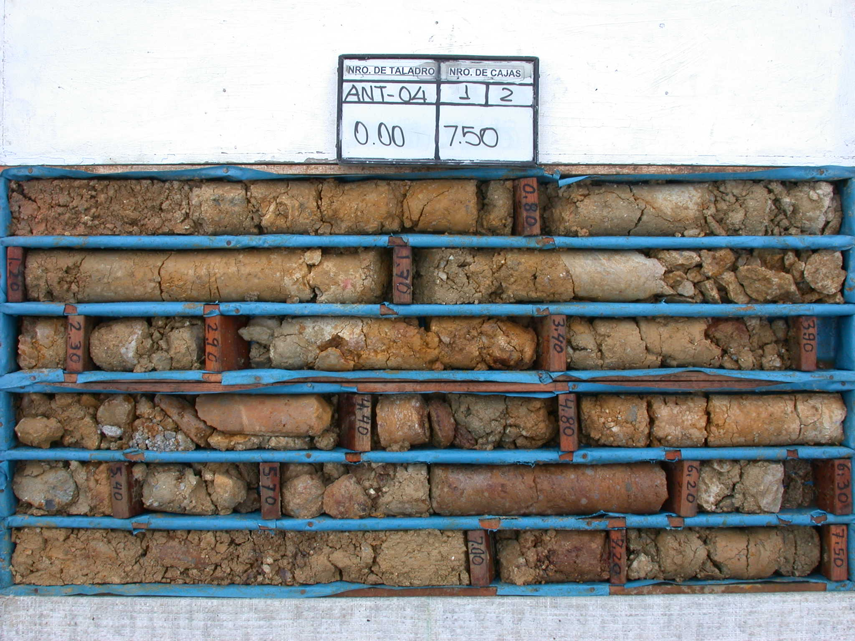

Section from the upper-left corner of the image showing a registration rectangle in image pixels, and from 0.0 to 0.8 meters downhole. The objective of the registration process is to select bracket individual sections of the core and tag them with their downhole locations so they can be “unraveled” back to a continuous view of what exists downhole.

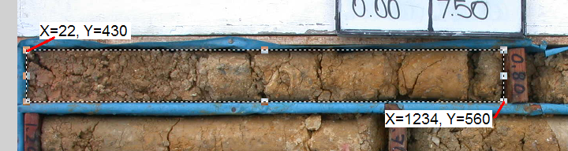

Example from another box of core showing registration rectangles for the entire box.

