Sun Microsystems #1
I. Overview
OpenSolaris is an operating system created by Sun Microsystems as a freeware operating system. This operating system allows users to freely create their own works and recreate other's works to redistribute across the web. As OpenSolaris has continued to develop, the project has matured to the point where customization of the installation is both desired and in order to keep down the size of the installation disc it is required. Software repositories are growing quickly, allowing users to download and install many different software packages. Therefore, the Sun Microsystems OpenSolaris team has requested that a web site be designed and built allowing potential users to select from these software packages and then download a corresponding disc image. This disc image, similar to Ubuntu, would then be able to either run live, or to also install OpenSolaris on the user's computer. Our project uses two Sun programs: the Distribution Constructor (DC) and the Image Packaging System (IPS) to create the ISO image (standard file extension to burn to a CD/DVD) of OpenSolaris.

II. Requirements
Below is a list of the steps we need to go through the create the Live CD/DVD image for the user.
- Website provides list of available packages.
- User picks the packages and the Distribution Constructor receives that information and tells the IPS to retrieve those packages
- After the packages have been retrieved the DC & IPS create an ISO
- An email is sent to the user providing a link to the ISO file
- The ISO image is deleted a certain amount of time after it is created.

III. Design
i. Assumptions
The web interface assumes a certain amount of experience on the user's part, partially due to time constraints, as well as the logical deduction that the user is relatively well-versed in computer use. For example, local descriptions of each of the packages will be minimal at best. Additionally, while there will be instructions on the usage of the site, there will be relatively little in the way of 'basic' tasks, such as burning the image to a disc. However, as users will undoubtedly want to preview the package before choosing to install it we included links to the respective pages of the repositories.

ii. Basic Design
Figure 1 (see next page) illustrates the basic flow of user input to make the ISO image. His or her name and e-mail address are the first required fields to be provided by the user. After each is given, by interfacing with existing repositories, the list of available packages is created. At this point, these packages are displayed for the user to select. The user may search for individual types of packages using a search field included on the page. Once this is complete the user submits his or her choices. Due to the amount of time required to compress the image, having the user wait on the web page would be irritating and unnecessary. After submitting his or her choices, the user is told to check their email as an email is sent to them once the DC has finished creating their image.

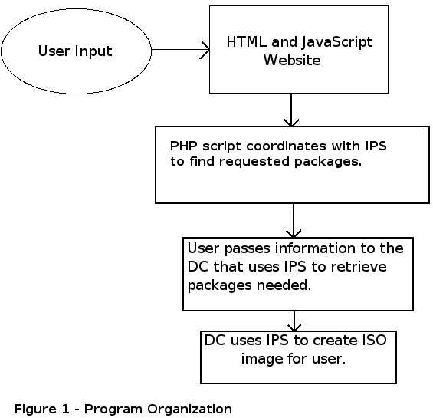
iii. GUI Design
Our software tool includes a few major parts. It begins with the web interface, which collects user data. It lists the available packages to put on an ISO file by using the IPS (Image Packaging System) to search for these packages. Our software then creates input for the Distribution Constructor (DC), which uses the IPS to retrieve what the requested packages. After collecting the appropriate data, the resulting XML manifest file will be validated, and passed to the DC. These are the major parts of our project and are explained below in greater detail. Each individual part has been laid out (Figure 2 on the next page) showing what code will be used for each part.
The web interface is our opportunity to communicate with the user and gather details of the user’s needs. The main function of the web interface is to take the information provided by the user and translate this data into a form accepted by the DC and IPS. However, to do this we must consider all the required functionality of the web site. This web site will incorporate two ideas. The first is to provide access to the OpenSolaris image to a large number of people, which is the whole objective of the Internet. The second is to create an attractive display with a well-developed user interface. It will be used as a basis for the GUI, but will have to be modified from an application to a website. This attractive display essentially creates the site to match the designs of all the other sites in the OpenSolaris domain. The well-developed user interface is dictated by our communication with Sun’s user interface specialist.
In order to exhibit the required functionality, we will use a combination of HTML, JavaScript, MySQL and PHP. These languages will help us create an interactive web site and will allow us to store information. PHP and MySQL are also used as the means to retrieve package lists, organize the input, generate the corresponding XML file, and then call the DC to begin the image generation. Our specific web site consists of a series of web pages, echoing a 'wizard' in its general look and feel. These web pages flow from section to section in order to create the ISO image. The most important of these steps allow the user to select from a list of packages to put on their ISO. To display the list of packages we use the IPS, incorporated in the OpenSolaris system.

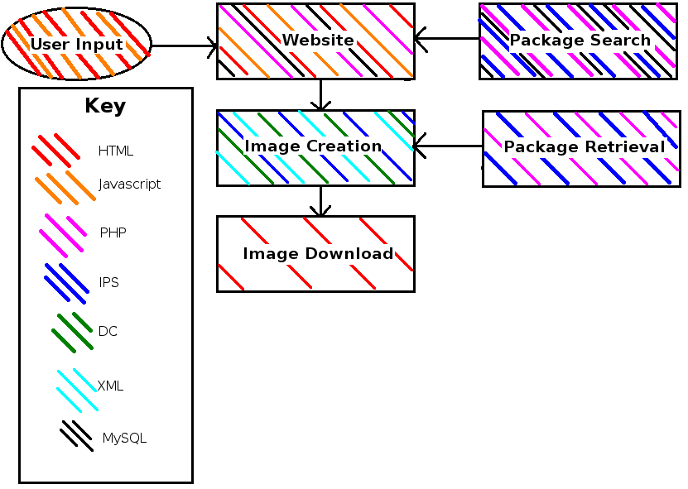
Figure 2 – Code used for each section
The IPS that comes preloaded on OpenSolaris operating systems is used to retrieve packages forthe system and install them. We are using the pkg(1) commands to retrieve packages. Since the DC will be using the IPS to create the ISO images, we are only using the IPS command, 'pkg search', to find packages and display them.
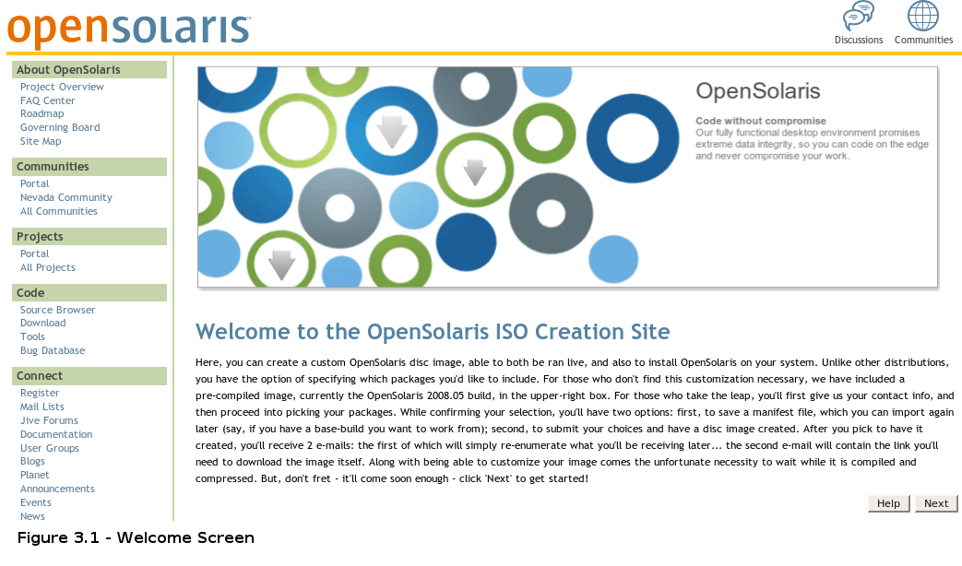
'pkg search' is the command that searches for a given token and display its information as the FMRI (Fault Management Resource Identifier). The standard search command is: pkg [-lr] [-s server] token. Where -l tells it to search the installed packages on the image. -r tells it to search the repository that is linked to the image. And -s searches for packages in the specified server. We inputed the server as one of many of the given servers that has a large repository of packages, and allowed the user to change repositories. As for the token, normally one would enter a keyword for the command to search for. Our searching however is done a little differently. Firstly a list is created using the search command searching for all available packages. Afterworlds this list is brought into the web page as the entire list of packages for the user to see. This list exists in a MySQL database and when the user searches for a specific package, the
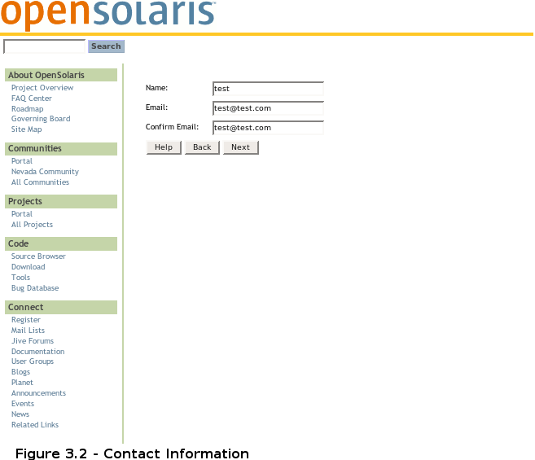
Once the IPS has found all the packages and our website has taken the information it formats it to be displayed on our website. The first page will be a simple informative page telling the user what they should expect and how the whole process operates (refer to Figure 3.1). The next few pages collect information from the user. These pages include a name and email address field (refer to Figure 3.2) and a box displaying information about the packages available and the packages chosen (refer to Figure 3.3 on the next page). On this page there is a drop down box that displays a list of repositories to choose from. This page displays all the packages available from the given repository along side check boxes. These check boxes are for the user to check to indicate which packages should be included in his or her customized version of OpenSolaris. The user may add or remove packages to his or her liking by checking or unchecking the respective boxes. To determine what packages are available from a given repository, we use the search command of the IPS as described previously, and parse the results to display in the box. A user may choose packages from any of these repositories. After this page there is a confirmation page that displays all the packages the user has chosen and asks the user to confirm that his or her contact information and included packages are correct.
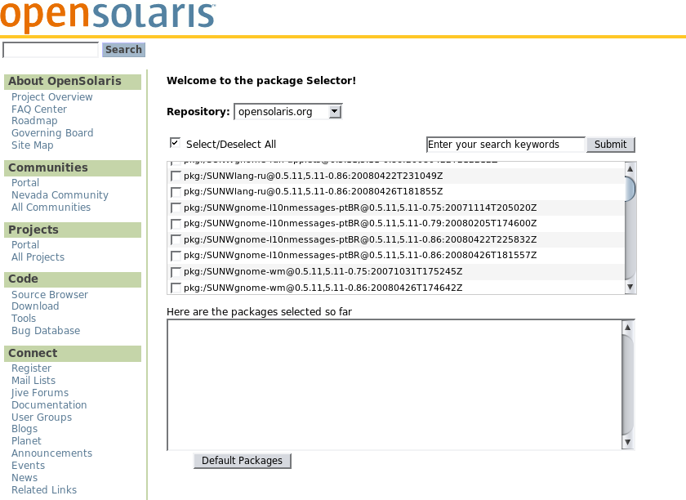
Figure 3.3 – Package Selection Screen

iv. Back-End Design
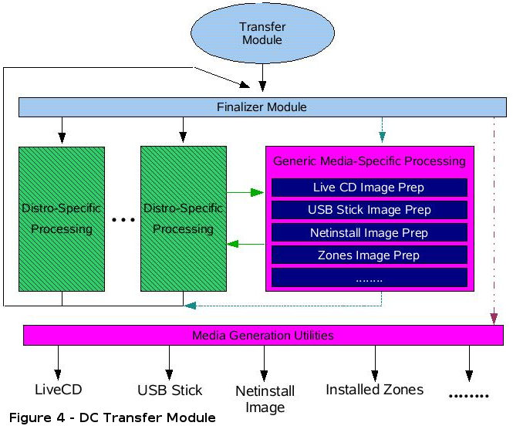
Unlike other distributions, which only allow for a limited number of choices (normally, desktop vs. server, x86 vs. x86_64, etc.), the online tool for ISO creation is much more robust; as such, it also requires a much more robust back-end to allow for this customization. As opposed to simply linking to a small number of pre-created images, this tool has to use Sun's internal image creation tools to create the ISO on request. The tool assembles the user's input into the format required by the DC. The DC then parses this data, and begins creating the image. The most integral part of the DC's operation occurs at the Transfer Module (refer to Figure 4); this is where the DC uses the IPS to make a base image, download, and then install the selected packages. After the image is updated, the DC then continues its operation, finalizing the image, performing any specific processing required, and then generating the final image. While the DC allows for multiple output-types, only the 'LiveCD' option will be used by this tool.
The main focus for the web ISO tool itself (as the DC and the IPS are Sun-managed), is to correctly form the file to pass to the DC. The file is an XML file (refer to Figure 5), utilizing its inherent nested structure to specify attributes for the live boot section, the installation section, and the disc as a whole. These attributes can range from packages to include to localization information to system preferences, and more. Much of this XML document contains default values, which are commonly valid. Therefore, the file specifies the packages to include, and then will use these default values to save both time and space.
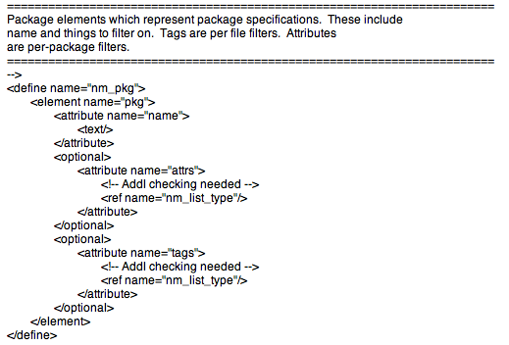
Figure 5 – Sample Section of DC XML Input

v. Image Creation and Download
To verify the XML outputed by the website we are using a validator provided by Sun Microsystems. This software takes an XML file and checks to make sure it is formatted correctly – ie are the correct tags in place, in the correct levels, etc. This will be a safety net, ensuring the website will be compatible with the final DC, irrespective of whether or not it is actually finished.
At this point this is as far as our project may proceed. The DC is being rewritten in Python and is not yet completed. As such we are asked not to proceed with the old DC as it would require them to change how we outputted or XML file. As such we are only to use the validator to ensure our XML is valid. We were unaware as to whether the DC would be completed or not when our project was completed so we continued on and planned what was to be done with that XML file.

Once we create and validate our XML files, they would be ready for the DC. Sun has already specified the syntax required to call it: `dist-const build [-R | -r stepname] [-p stepname] [-q] <manifest-file.xml>`. The distribution constructor supports checkpoints, and resuming from these checkpoints; since a)it is beyond the scope of this project, and b)is not yet implemented, the web tool will not utilize any checkpointing features. Therefore, the call that would be used by the tool will instead be `dist-const build <manifest-file.xml>` - a much simpler statement. The call would be made from a bash script
After the user submits their information, and the DC begins its work, a number of challenges arise. First, something must be put in place to handle images after they have been formed and downloaded. At sizes in the area of a DVD, the space needed by the tool could increase dramatically with usage. Instead of trying to have each image deleted on its own schedule, a common directory will be made for all the images. This directory, by means of a cron entry, is to be cleared 24 hours after the image is created. Having a single cron entry set up beforehand reduces the strain in the short-term; the tool would be designed to allow for as many changes as possible, which could include this improved deletion system.

VIII. Conclusion
Overall, while this iteration of the web tool was not entirely robust, it incorporated sufficient functionality to accomplish the basic task of creating a disc image, and was also designed to allow for extensibility. As the OpenSolaris platform continues to develop, so should its download and installation procedure; the tool should be plastic enough to allow for such changes. With these features in place, the web ISO creation tool will be able to handle OpenSolaris distribution for the foreseeable future.

i. Problems and Errors
The project went as planned for the most part. Obviously for one thing not having a working DC kept us from completing Sun's original plan for our project. We completed an XML file however that does match to the validator provided by Sun.
We ran into some trouble with running MySQL as well. Originally our pages were on a server with an OpenSolaris operating system. However running MySQL and PHP together wasn't working as well as it should have. MySQL was installed into a different location than where PHP was looking for it and would not allow for any changes. As such we switched our server over to an Ubuntu operating system.

ii. Want to Include/Future Work
There were a couple of things that we wanted to do differently or include, but time prevented us from including them. Firstly, with multiple repositories comes the chance of having multiple packages of the same thing. For instance on the package site: blastwave.org a package might be named firefox1.0. While on the pkg.opensolaris.org site the same package might be called simply Firefox. We would have wanted to do a comparison of packages names to make sure that the user isn't getting the same package twice and taking up more space on his or her image.
Another thing we'd have liked to do with the packages is a package description. There is a package command, pkg info, that displays the information about a package. We'd have either liked to do it so that once the mouse is rolled over or once a package is clicked on, the information is displayed for the user to see.
There were a few things that'd we would have liked to add to the website as well. Firstly is information that goes into the XML file that gets parsed into the DC. You can change the root user, password, or add additional users, etc. An additional page could be added to the website that asks the user for this information and more. Another feature would be both for users to save and upload their XML files. This way they can continue it later if they have to stop. This would also have another purpose. We could create XML files that are a basis for user to star out at. For example XML files that include package meant for web-programming or meant for editing current OpenSolaris packages.
There is definitely room for future work on this project as we are sure Sun will expand on it and possibly use it on their actual website. The Distribution Constructor will be finished in Python and could then be applied to the site to actually create an ISO image for users to download. While our site does everything up to using the DC, actually getting the image to be produced is a large step. However once the XML file is created, using the DC isn't more than a couple of command calls away. Additionally there is room for this site to grow. While we did create the site to look like OpenSolaris' it would be easy to recreate the site taking the “wizard” part and placing it into another site. We have also included comments throughout our project as it is easier to identify certain parts and to modify them.

